Project Report On

Book reader

Book reading system

Ninjeng Lama

00175018

Computing Project

Level 5 Diploma in Computing

Softwarica College of IT & E-Commerce

Kathmandu, Nepal

Submission Date: 12th July

Submitted to: NIMAN MAHARJAN

Table of Contents

Chapter 1: Introduction 3

1.1 Introduction of the project 3

1.2 Background of the project 3

1.3 Overview 3

1.4 Aims and objective 4

Chapter 2: Analysis 5

2.1 Introduction 5

2.2 Feasibility study 6

2.3 Requirement analysis 7

2.4 Use case diagram 10

2.5 NLA (Natural language analysis) 11

Chapter 3: Design 14

3.1 Introduction 14

3.2 Structural design 14

Class diagram 14

Data flow diagram 18

3.3 Behavioural design 20

Activity diagram: 20

Sequence diagram: 22

3.4 Database design 28

Entity relationship diagram: 28

Data dictionary 30

3.5 Architecture 31

3.6 User interface design 32

Chapter 4: Implementation 38

4.1 Introduction 38

4.2 Programming language 38

4.3 Coding and user interface. 38

Chapter 5: Testing 39

1. White box testing. 39

2. Black box testing. 51

Chapter 6: Other project issues 69

6.1 Risk management 69

6.2 Configuration management 70

6.3 Project issues 71

6.4 Limitation 71

6.5 Future work 71

Chapter 7: Conclusion 71

# Chapter 1: Introduction

## Introduction of the project

In the modern period like now people don’t only read books form textbook or go to library for research they can read/research from the mobile, iPad and different other devices through internet. So, I am developing a project named “**Book reading system”** which help the user to read book at any places as they please. It is an electronic version of tradition printed book that can be read by using smart phones. The project is a type of eBook application software like Kindle, caliber etc.

## Background of the project

The project is an initiative to solve the problem faced by the general people or the students to read books while traveling or at home. It is hard and boring to read books while traveling or just reading at home sometimes. So, I build an android project which will make reading easies by making the book inside the phones or tablet or iPad so that user don’t have to carry heavy books, don’t have go to a public library to read, they can read any books instantly anywhere within an internet.

## Overview

I will be using waterfall methodology to develop the project because it a traditional method of software development. The reason to use waterfall method to develop Book reading system are:

* The method is simple and easy to understand
* It is best method for smaller project where requirements are well understood.
* Each step needs to be complete to move to another steps.
* It is easy to track the development of the system.

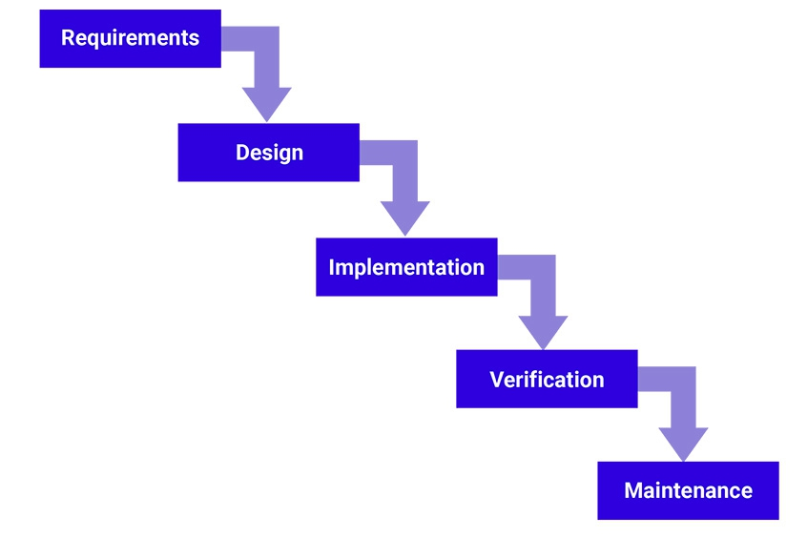

## 1.4 Aims and objective

**Aims**

If a person doesn’t have his/ her aims in life, then they will be clueless for their future. The same theory applies in software development also. If the software doesn’t have aim than making the software is waste of time. The main Aims to develop the Book reading system are shown below:

1. To develop an android application which can store books written by famous author and make the book available to read to any user how uses the application.
2. To make it portable for user so there is no burden while reading.
3. To make it more environmentally friendly than Printed books/ Physical books.
4. To make it easy for the reader so that they don’t even need to go out of the house to borrow books from local libraries.

**Objectives**

The main objective to develop the Book reading system are given below:

1. To develop an electrical reading system so that user can read them any time and places they please.
2. To learn Java programming language to increase my knowledge.
3. To test if I could learn a new programming language and create a software within 3 months.
4. To learn various means and methods for the analysis and researches in real projects.
5. To make a daily useable application to make life easy.

# Chapter 2: Analysis

The analysis section of the book reading software is divided into subsections. The subsections are:

1. Introduction
2. Feasibility study
3. Requirement analysis
4. Use case
5. NLA

## 2.1 Introduction

Analysis in a project means the realization of what the project is trying to achieve. In other word division of complex topics into smaller topics in order to gain better understanding and output. It is an important phase of development it is done to gain better understating of clients’ needs and benefits they desire from the project, to make strategy, to calculate the output, requirement gathering etc. The activities that are involved in analysis is shown below in the diagram.

**SWOT analysis:** Is a technique to understand strengths, weakness, opportunities and threats of an organization etc. Using SWOT analysis will be benefitable in Book reading system because it will help to support in more decisive and knowledgeable decision making. The SWOT analysis can:

1. Helps us clear the misunderstanding and unambiguity related to the requirements and client’s needs.
2. Helps us to focus on the strength of the application.
3. Find the weakness and try to improve it.
4. Makes it possible to achieve the success in project with high probability.
5. Change according to the technology when there are any opportunities.

## 2.2 Feasibility study

A feasibility study is an analysis that takes all the project relevant factors like economic, technical, legal and scheduling to ascertain the likelihood of the project. In many projects feasibility study is used to determine the pros and cons of the project like what must they spend their time and money on etc.

Feasibility Study helps us to determine:

* Whether the proposed system is cost effective or not.
* Whether the proposed technology is available or not.
* Whether the system can be developed within time or not.
* Whether it is legally accepted or not.
* Whether the system meets user requirements or not

So, for the Book reading system using feasibility study to determine if the project is worth developing or not. What are the pros and cons of the system and what can be done to make it better? The feasibility study is divided into five types and they are:

1. **Economic feasibility:**

This feasibility study determines is the project is feasible in terms of monetary. It calculates the total cost, return of investment and compares it so that the project is economically feasible to develop or not.

1. **Technical feasibility:**

This feasibility study determines if the technical resources available on the project meet the capacity or not. Whether the technical manpower capable of converting the ideas into working system. The technical requirement needed for my book reading project are laptop, supportable hardware etc.

1. **Schedule feasibility:**

This feasibility is the most important type of feasibility which keeps the track of time. Which means that the study determines whether the system can be developed in estimated time or not.

1. **Operational feasibility:**

This feasibility study determines if the system is supportable by the users or not. It is also a study of changing from older version to newer version. As I have implemented SWOT analysis for the Book reading system the analysis will identify all the strength, weakness, threats etc. which will help in operational feasibility.

1. **Legal feasibility:**

This feasibility identifies does the product met all the permitted and ethical requirement? The Book reading system that I am going to create meets all the legal and law of my country. So that it may not cause any trouble while developing the project.

## 2.3 Requirement analysis

Requirement analysis is the process of defining the expectation of the users for an application that is to be build or modified. Therefore, requirement analysis means to analysis, document, validate and manage the software requirement.

In the requirement analysis I will be using some of the method to identify all the requirement that are needed for the book reading system. The methods to identify the requirement are shown below:

1. **Functional requirement:**

The functional requirement defines the functions that are carried out in the system. It describes the system’s behavior.

|  |  |  |  |  |  |
| --- | --- | --- | --- | --- | --- |
| PF.ID | Function | Data | Rational | Dependency | Description |
| PF1 | Login | User input (Username and password) | For security purposes | No dependency | User can login to their personal account. |
| PF2 | Personal account | No data | Personal library | PF1 | User all data are stored here. |
| PF3 | Add books | Text document | Publishing new books | PF2 | To add books. |
| PF4 | Font adjustment | Text document | To make system user friendly | PF3 | To increase book reading experience of user. |
| PF5 | Voice reader | Text document | To make system user friendly | PF3 | To save time of readers. |

1. **Non-functional requirement:**

The non-functional requirement specifies criteria that judge the operation of the system, rather than specific behaviors. Some typical non-functional requirements are scalability, availability, maintainability etc.

|  |  |  |  |  |
| --- | --- | --- | --- | --- |
| PF.ID | Function | Rational | Dependency | Description |
| NF1 | Usability | To develop a system which can be used by all people. | PF1, PF2 | The system must be usable and easy to user for the user. |
| NF2 | Performance | To provide result faster. |  | The system should be able to analyse the sentiments within a short time depending upon the overall volume of words to be analysed. |
| NF 3 | Reliability | To provide a reliable system that has less failure |  | The system should never fail at its functionality and should have less MTBF (mean time between failures) |
| NF4 | Scalability | To handle the load of data |  | The system should handle the load of incoming all data. |

1. **MoSCoW prioritization:**

The method is a prioritization technique used in project management, software development to reach a common understanding between the stakeholder on the importance they play in the requirement.

The term MoSCoW is an acronym which all capital letters have their meaning the full form is (Must have, should have, could have, Won’t have).

* Must have: requirement must have labelled as must have are the critical and is success to be implemented.
* Should have: requirement labelled as should have are important but not necessary to be implemented.
* Could have: requirement labelled as could have are desirable but not necessary.
* Won’t have: requirement labelled as won’t have been agreed by stakeholder as not appropriate requirement for the time.

|  |  |
| --- | --- |
| Requirements | MoSCoW |
| Login | Should have |
| Personal account | Must have |
| Add book | Must have |
| Font adjustment | Should have |
| Voice reader | Should have |
| Usability | Must have |
| Performance | Should have |
| Reliability | Should have |
| Scalability | Must have |

## 2.4 Use case diagram

Use case is one of the dynamic behavioral diagrams of UML which shows what the Function are in the system and interaction between user and system. Use case consist of actors, use cases, relationship between them etc. A single use case diagram captures the functionality of a system. The Purpose of using use case is to capture the dynamic aspect of a system. The use case diagram of Book reading system is shown below:

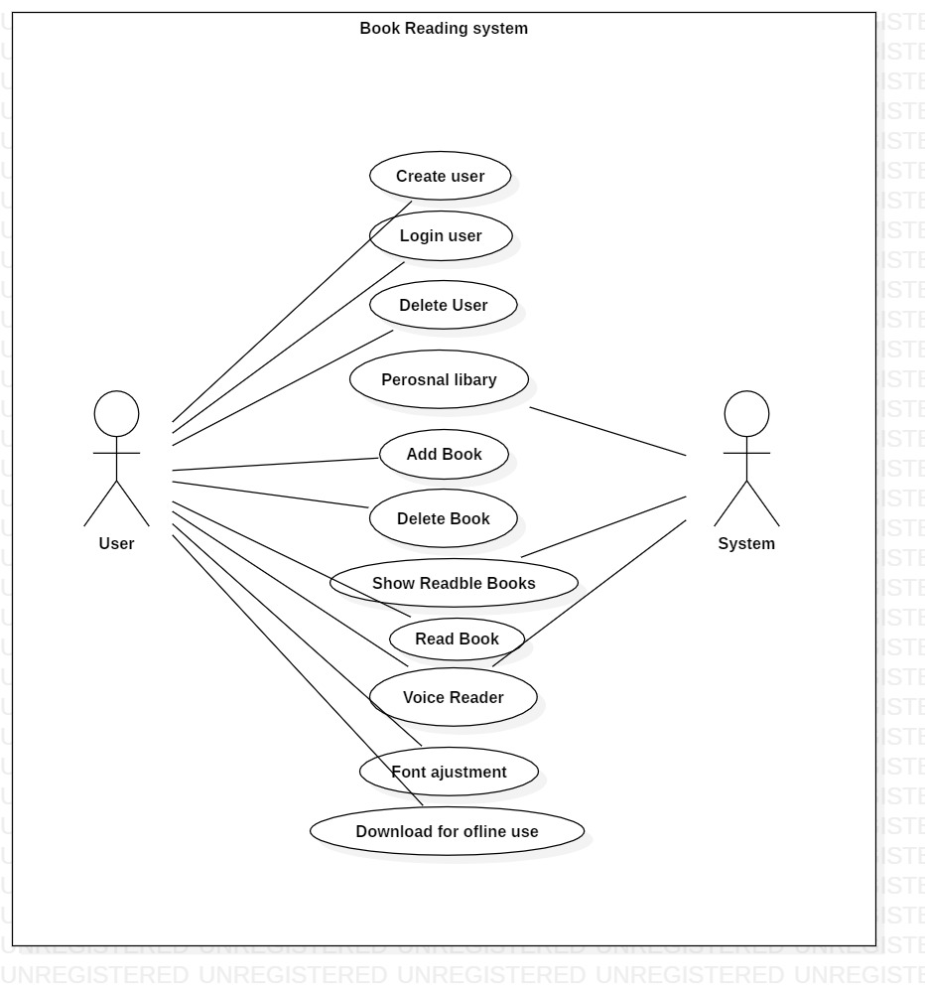

Fig: Use case diagram of book reading system.

## 2.5 NLA (Natural language analysis)

**Scenario**

The time is changing as we speak and as well as the technology. The people are getting modern day by day. The people can share every single detail to a certain person who is in the other side of the world. The development of technology is also affecting the modern education process, In the modern education process people don’t only read form textbook or go to library for research they can read/research from the mobile, iPad and different other devices through internet. Similarly, you been assigned to develop a project named “**Book reading system”** which help the user to read book at any places as they please.

It is an electronic version of tradition printed book that can be read by using smart phones. The project is a type of eBook application software like Kindle, caliber etc. The programming language to develop the application will be Java because it is the most popular language for developing mobile application.

While adding new book the details must be given like: Title, author, year, publisher, document type, volume etc.

Your task for the assignment is to implement the following function on the application

* Permits users to be added, and removed from the system.
* Books to be added, removed from the system.
* Font adjustment features should be implemented while reading books.
* Voice reader activation must be provided.
* Personal library after user have logged in.
* Books can be downloaded for offline use.

**NLA of the scenario**

The NLA (Natural Language analysis) is a process to analyse the scenario and provide proper Classes, method and Attributes by selecting all the nouns, verbs and adjective form the scenario. For example, we are provided with a scenario where we analyse the requirement and filter the candidate classes and candidate method.

Selecting all the nouns and verbs from the scenario

|  |  |
| --- | --- |
| Nouns | Verbs |
| Time, technology, people, modern, days, person, world, technology, education, book, library, book, user, book, electronic, traditional, read, eBook, application, software, | User added, user deleted, user update, book added, book removed, font adjustment, voice reader, personal library, download books. |

Identifying candidate class for book reading system.

|  |  |
| --- | --- |
| SN | Candidate class |
| 1. | User |
| 2. | Book |
| 3. | Library |

Identifying Candidate verbs from the scenario.

|  |  |
| --- | --- |
| SN | Verbs |
| 1 | Add user |
| 2. | Remove user |
| 3. | Update user |
| 4. | Add books |
| 5. | Remove books |
| 6. | Font adjustment |
| 7. | Voice reader |
| 8. | Personal library |
| 9. | Download books |

Class diagram of Book reading system.

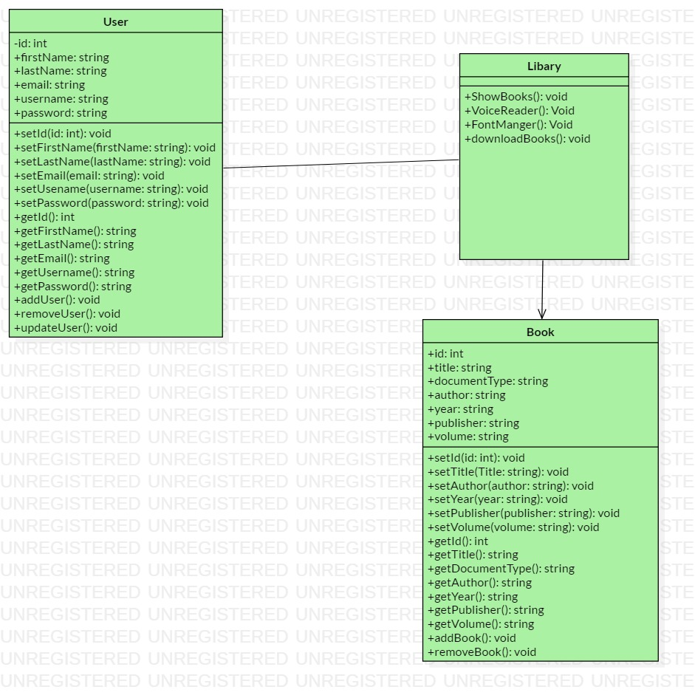

# Chapter 3: Design

## 3.1 Introduction

The phase design is the process of converting user’s needs into a suitable form, which helps the programmer in coding and implementation of software development. In the design phase, many critical and strategic decisions are made to achieve the desired functionality and quality that the Book reading system required. These decisions are taken into account to successfully develop the software and carry out its maintenance in a way that the quality of the end product is improved. The types of software design are:

1. Structural design
2. Behavioral design
3. Database design
4. Architecture design
5. UI design

## 3.2 Structural design

Structural design is the methodical investigation of the stability, strength and rigidity of structures. The basic objective in structural analysis and design is to save time so that good quality of code can be written in minimum time and effort.

The reason to use structural design is that:

1. It describes the architecture of the system.
2. Shows the interrelated components of the system.
3. To understand and calculate the stability, strength and rigidity of structures.

### Class diagram

The class diagram is one of the UML (Unified modeling language) static diagram which describes the static structure of the diagram by showing classes, attributes, operations and relationship between the classes/ objects.

The purpose of using class diagram are:

1. It shows the static structure of the system.
2. It has its own simple notation which are simple and easy to use.
3. Helpful for developers to understand the system easily.

Notation that are used in the Class diagram are:

Class notation

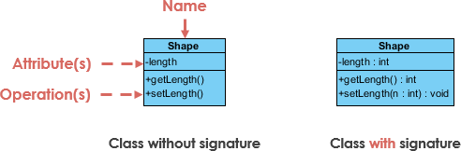

In the above figure the Shape is the name of a class, whereas length is the attributes and getLength () and setLength () are the operation or the function of the shape class. This is how the class is created.

Class relationship notation

1. Inheritance or generalization

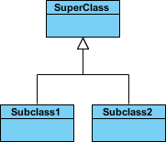

A solid line with a hollow arrowhead is stretched from the child class to the parent class which denotes that the SuperClass can use attributes, operations from the Subclass1 and Subclass2.

1. Simple association



A solid line connection class1 and class2 is know as simple association which means they are connected to each other’s.

1. Aggregation



The aggregation is denoted by a solid line with an unfilled diamond at the association end connected to the class of the composite. The relationship implies that the child class and exits independently of the parents. Example the class2 can still exits if class1 is deleted.

1. Composition



The Composition is denoted by a solid line filled diamond at the association connected to the class of composite. The relationship implies where the child cannot exist independent of the parents. Example if Class1 is deleted then class2 will not have any value so it cannot operate without class1.

1. Dependency



The Dependency is denoted by a dashed line with an open arrow which exists between two classes if changes to the definition of one may cause changes to the other but not the other way around. Example class1 can change it operation and that operation can be used by class2 but if class2 changes than if won’t be implemented in class1.

Class diagram of Book reading software:

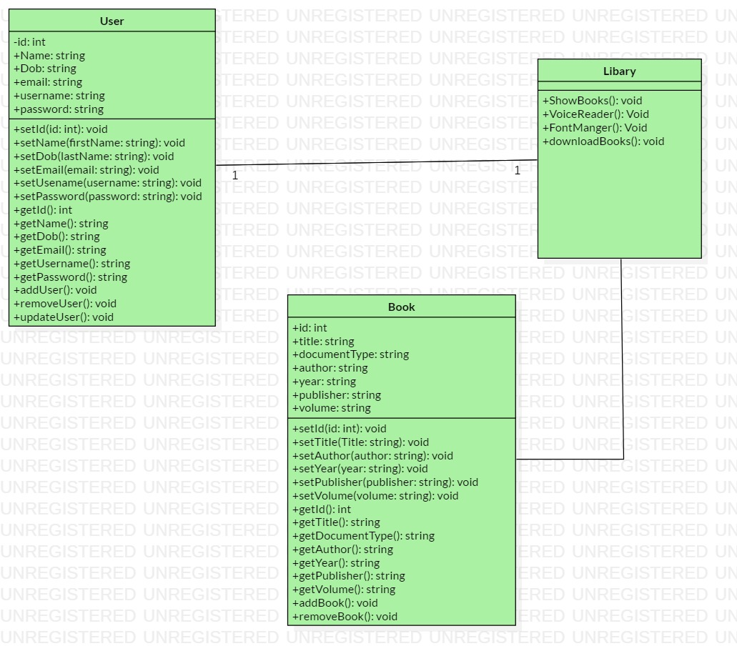

### Data flow diagram

The way of representing the flow of data of a process or a system is known as data flow diagram. The data flow diagram describes the process that are involved in a system to transfer data from input to the file storage and report generation. It uses defined symbols like rectangles, circles and arrows, plus short text labels, to show data inputs, outputs, storage points and the routes between each destination. (What is Data Flow Diagram?, n.d.)

The purpose of using DFD diagram are:

1. It represents the function which capture, manipulate, store and distribute data between system.
2. Simplicity of notation.
3. Determination of physical system construction requirement.

There are two types of data flow diagram notation one of them is called Yourdon and Coad and other one is called Gane and Sarson.

Notation used in data flow diagram are:

|  |  |  |
| --- | --- | --- |
| **Notation** | **Yourdon and Coad** | **Gane and Sarson** |
| External entity |  |  |
| Process |  |  |
| Data store |  |  |
| Data flow |  |  |

1. External entity: Outside system which sends and receives data, communicating with the system.
2. Process: The change of data producing an output is know as process.
3. Data store: Files and repositories that holds information for later use.
4. Data flow: The route that data takes between external entities, process and data store is known as data flow.

The data flow diagram of book reading system is shown below:

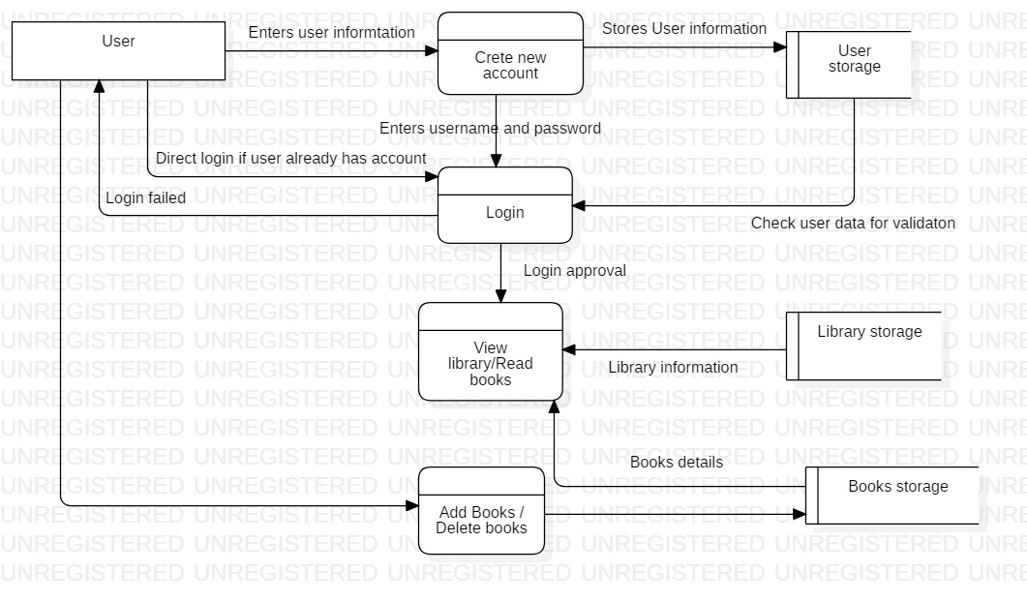

## 3.3 Behavioural design

Behavioral design shows the dynamic behavior of the system and its executing. So, to represent the behavioral of the book reading system I have shown Activity diagram, Sequence diagram.

### Activity diagram:

The activity diagram is one of the UML’s diagram which describes the dynamic aspect of the system. Activity diagram is also a type of flowchart which represent the flow of activity in the system. The Purpose of using activity is to capture the dynamic behavior of the system. It is not only use to visualizing the dynamic nature of the system, but also to use to construct the executable system by using engineering techniques. The activity diagram deal with all type of flow control by using different element like Control flow, Fork, join, Decision etc.

The purpose of using Activity diagram are:

1. To capture the dynamic behavior of the system.
2. To draw the activity of the system.
3. Describes the sequences from one activity to another activity.

Notation that are used in Activity diagram are:

|  |  |  |
| --- | --- | --- |
| **Symbol** | **Name** | **Description** |
|  | Start Symbol | This represent the start of the process or the workflow. |
|  | Activity symbol | Indicates the activities or the process. |
|  | Action flow symbol | Shows the direction flow or control flow. The pointer represents the flow. |
|  | Decision symbol | This symbol represents the branching or merging of various flows with the symbol acting as a frame or container. |
|  | Fork symbol | Splits a single activity into two concurrent activities or more. |
|  | Joint symbol | Combines two concurrent activities into one single activity. |
|  | End symbol | States the end of activity or completion of flow. |
|  | Note symbol | Allows the diagram creator to leave message or note. |

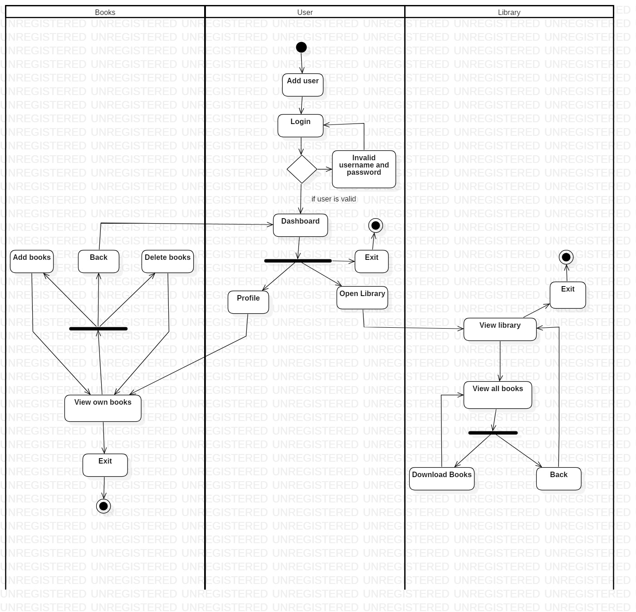

The above activity diagram is of Book reading system where there are there swim lanes. Where user firstly creates a new account after he creates it, he/ she login if the username and password is valid then the user proceed to dashboard, if not then back to Login. In the dashboard the user has two option he/she can read books directly by Open library or can go to he/she profile where the user can add book, delete there books etc. in the open library the user can other written books as well and can also download it for offline reading.

### Sequence diagram:

Sequence diagram is an UML diagram which shows how operation are carried out. It captures the interaction between object. Sequence diagram captures the interaction between user and system. The diagram is time focused and determines the time used by a function.

The purpose of using sequence diagram are:

1. The interaction between user and system is high level.
2. Help to discover architectural, interface and logical problem early.
3. Interaction between object within a collaboration that realizes an operation.

Notation that are used in sequence diagram are given below:

|  |  |  |
| --- | --- | --- |
| **Symbol** | **Name** | **Description** |
|  | Actor symbol | Shows entities that interact with each other. |
|  | Life line symbol | Represent the passage of time. The longer the line the more the time. |
|  | Object symbol | Represent a class or object. |
|  | Activation box | Represents the time needed to complete the task. |
|  | Package symbol | It can be used for labeling the diagram or can contain interactive element of the diagram. |
|  | Option loop symbol | It is used to model if or then scenarios. |
|  | Alternative symbol | It is used for if else scenarios. |
|  | Asynchronous message | Used to send message and continues to next step. |
|  | Synchronous message | Used to send message and wait for the reply. |
|  | Synchronous return message | It is used to send replay message or return message. |
|  | Lost and found message | A lost message contains a dot at the end of the arrowhead to indicate the destination is unknown. A dot at the source of the message indicates a found message with an unknown sender. |

The sequence diagram of book reading system are given below:

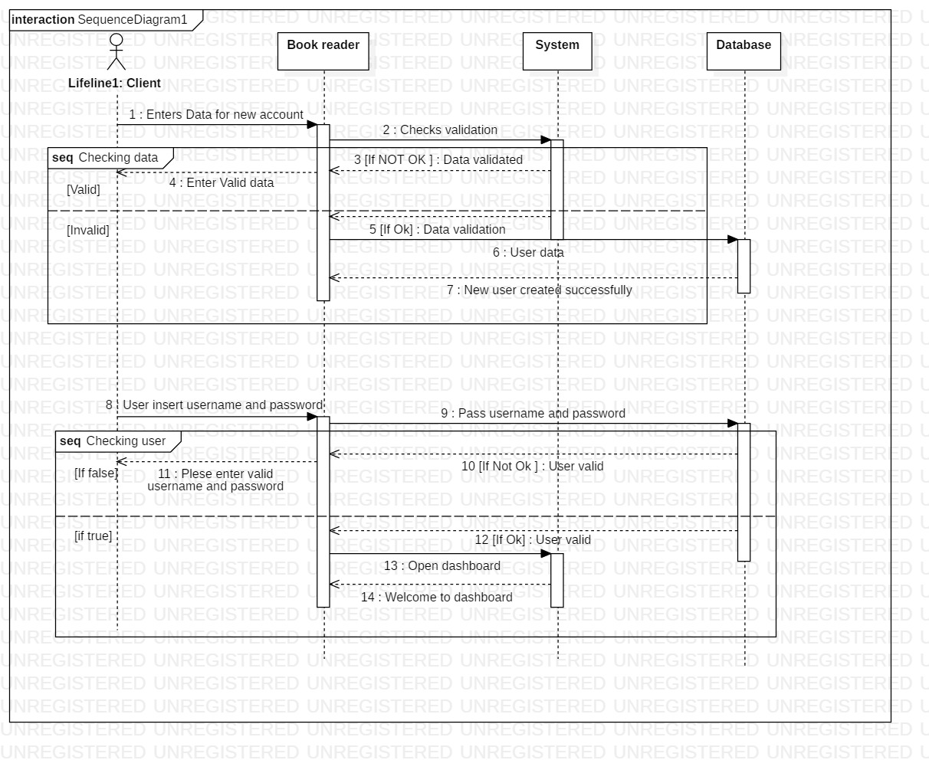As we can see in the figure, Firstly the user creates enters his/her information to create a new account then the data goes to validation if the data is Ok then it goes to the data base and entry is made where if the data was not ok or valid then a message is send to the user saying please enter valid data. After the user has created the account, they can login. In the login process if the username and password is valid then the user goes to dashboard if not then the user gets an message saying the username and password is invalid.

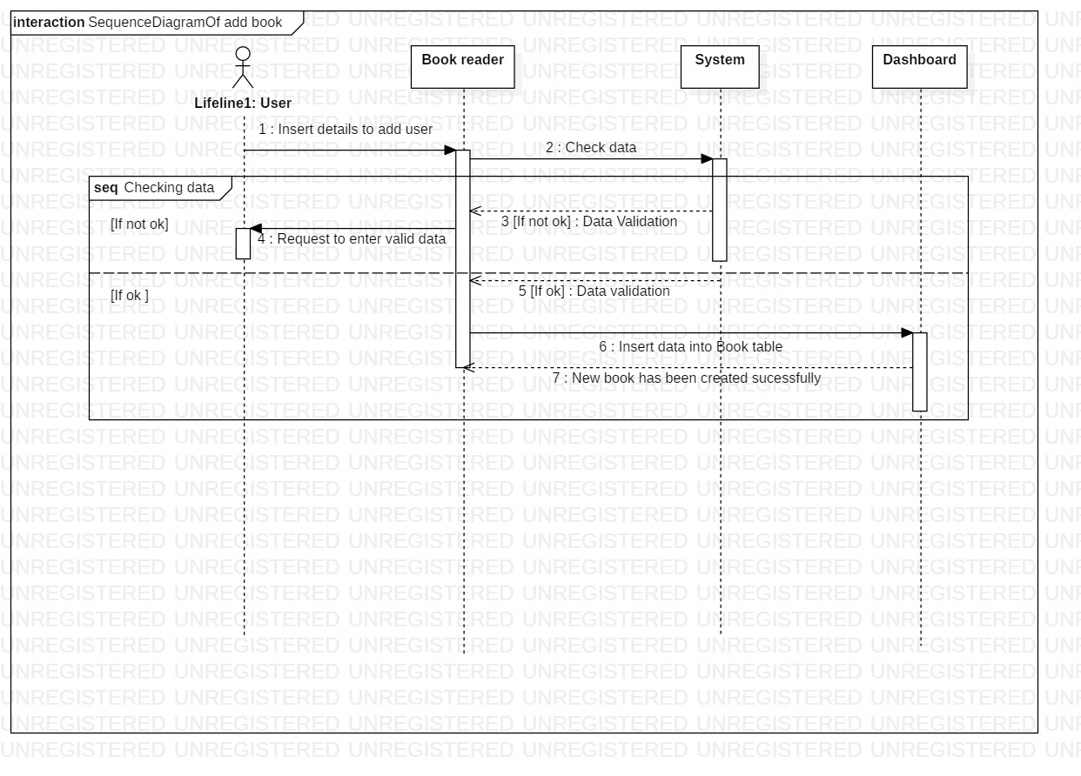

While the user has logged in the user can add book to their profile. In the figure user insert data that are needed to add book then the action is taken place the data goes to the system to check the data is valid or not it the data is not valid then user gets a message to reinter valid data. If the data is valid then the data does to the database and the book will be added.

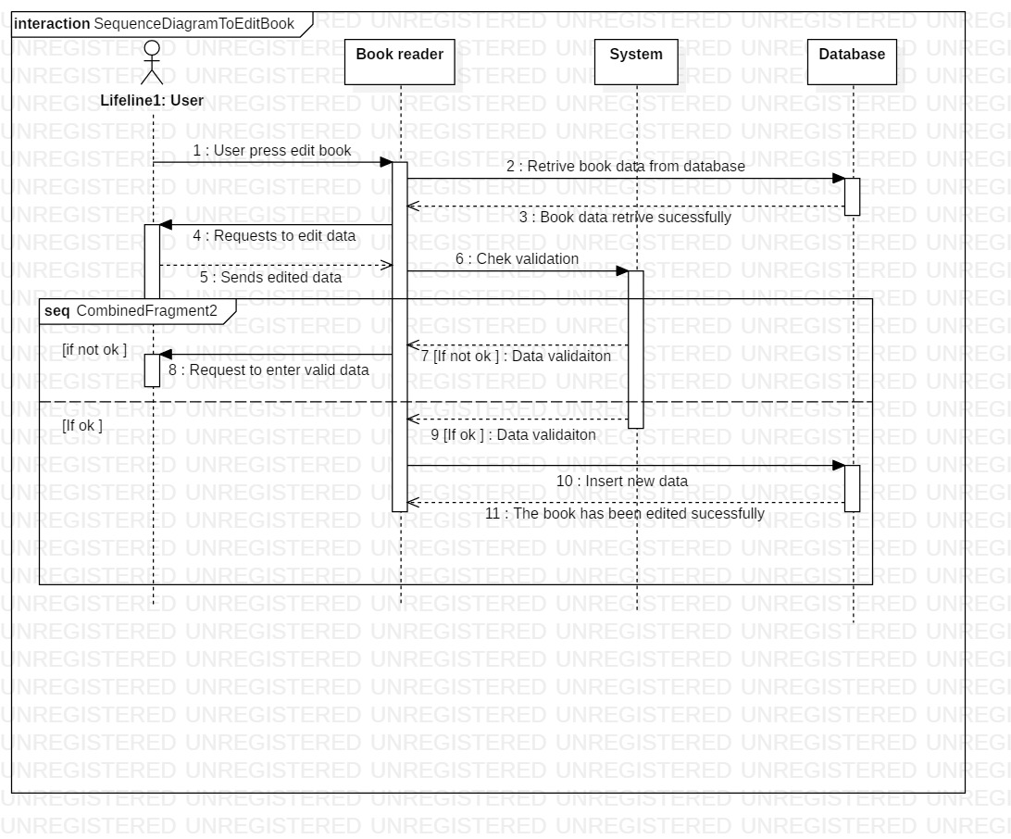

If the user wants to edit the book that are already added then the process is shown in the above diagram. The data is retrieved form the database and shown the book reader where the user can change the data. After the data is changed by the user it goes to the system to check if the data is valid or not. If the data is valid then it goes to the database and the book will be edited successfully. if the data was invalid then the user is requested to enter valid data.

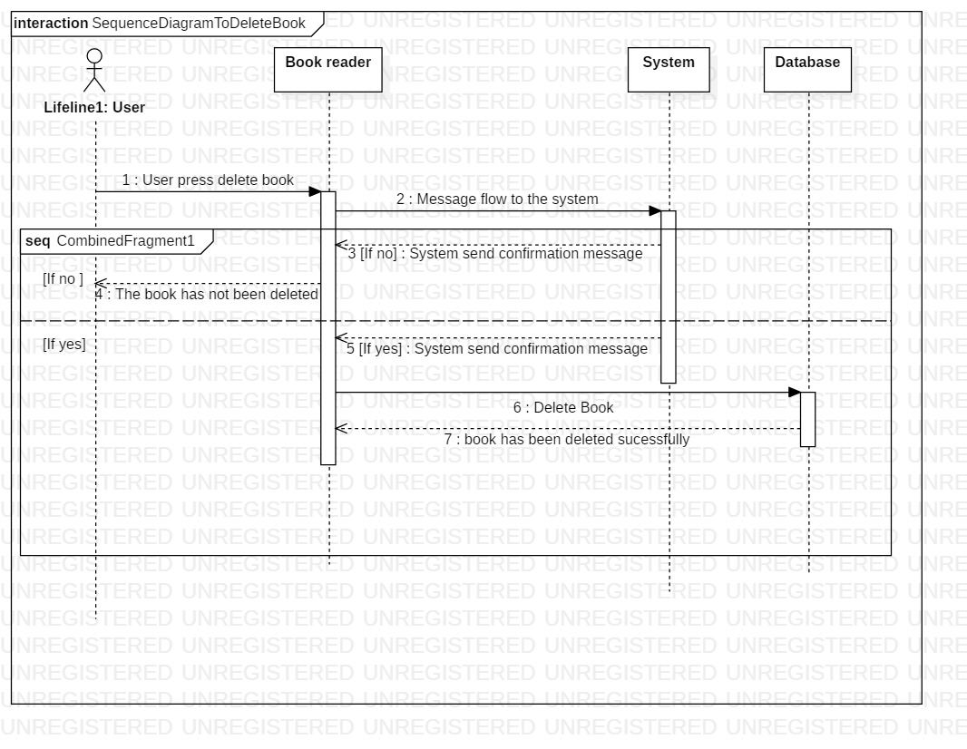

To delete a book user press, delete where the command goes to the system and the system send a message to the user to confirm the delete. If the user says yes then the message is sent to the database to delete the book. If the user says no then a message is sent saying the book is not deleted.

## 3.4 Database design

The database design helps us to provide logical structure of the system and how data are stored, organized and manipulated. In the database design I will explaining two diagrams for the book reading system and they are:

### Entity relationship diagram:

The Entity relationship diagram is a type of flowchart shows how the entities are interrelated or connected to each other. It also helps us to view all the data that are stored in the certain table or individual table of the database.

The purpose of using ER-Diagram are:

1. ER provides a visual starting point of database design.
2. Helps us to determine information system requirement.
3. A conceptual data model, which lacks specific detail but provides an overview of the scope of the project and how data sets relate to one another.

There are many types of ER -diagram and they use different notation and they have their own style. The notation I have used to create the ER- diagram for the book reading system is Crow’s foot because it is simple and easy to understand.

The notation of Crow’s foot:

|  |  |
| --- | --- |
| Symbol | Name |
|  | Entity symbol |
|  | Attribute symbol |
|  | Zero to many relation |
|  | One or many relation |
|  | Zero to one realtion |
|  | One to one |

ER diagram of book reading system using Crow’s Foot notation.

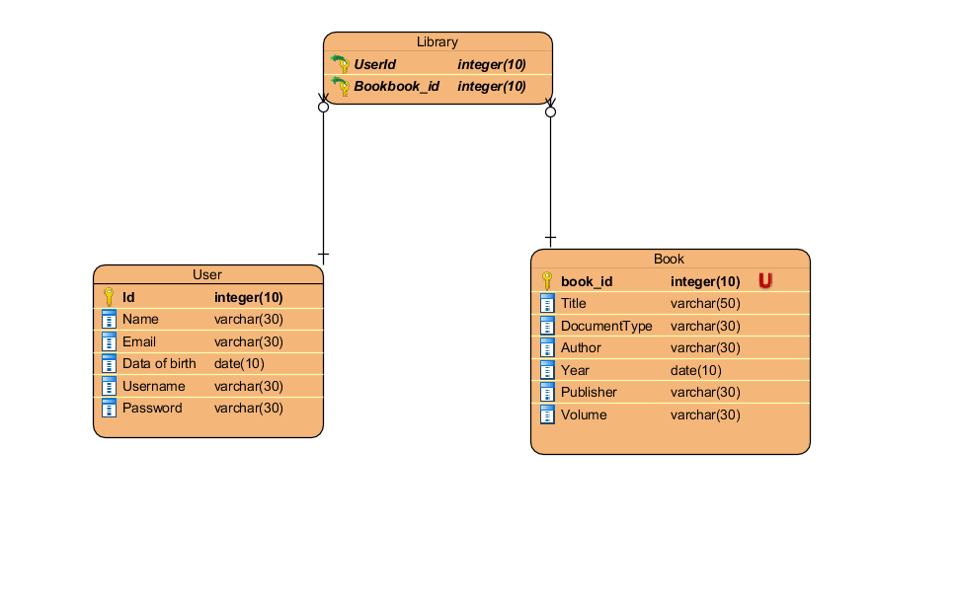As u can see in the above figure there are three tables (User, Book and library) where user the table keeps the records of details like name, email, dob, username, password) etc. where as book keeps the records of books that are going to be added etc. since the book and the user have many to many relationship between them so an associative table is developed which is named Library.

### Data dictionary

Data dictionary is a description of data or items of data which helps the programmer in need. The data dictionary also falls in the database design because it gives brief explanation of the data that are used and what are their roles. The data dictionary diagram of the book reading system is shown below:

|  |  |  |  |  |  |  |
| --- | --- | --- | --- | --- | --- | --- |
| Entity name | Column name | Data type | Length | PK/FK | Nullable | Unique |
| User | Id | Int | 10 | PK | False | True |
| Name | Varchar | 30 |  | False | False |
| Email | Varchar | 30 |  | False | True |
| Date of birth | Date | 10 |  | False | False |
| Username | Varchar | 30 |  | False | True |
| Password | Varchar | 30 |  | False | False |
| Book | Book_id | Int | 10 | PK | False | True |
| Title | Varchar | 50 |  | False | False |
| Document type | Varchar | 30 |  | False | False |
| Author | Varchar | 30 |  | False | False |
| Year | Date | 10 |  | False | False |
| Publisher | Varchar | 30 |  | False | False |
| Volume | Varchar | 30 |  | False | False |
| Library | Userid | Int | 10 | FK | True | False |
| Bookid | Int | 10 | FK | True | False |

## 3.5 Architecture

Architecture describes the system major components, relationships and how they interact with each other’s. The software architecture also serves as blueprint of the system. The book reading system consists of three tires of architecture (interface or user, logics or server and the database). The interface shows the user information that helps to interact with the system. The logics defines the process and defines the nature of the system. The database keeps stores, provide all the necessary information that are need for the user to use the book reading system. The concept of the three tires method is to manage the system properly so that the system can be changed and managed properly.

The Architecture of the book reading system is shown below:

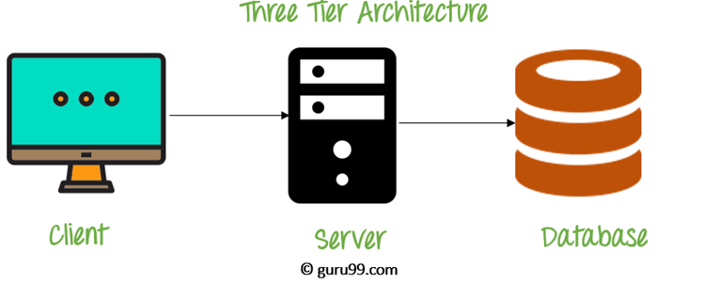

## 3.6 User interface design

The design of machine and computer for better usability of the product to the user is known as user interface design. User interface design is to maximize the usability and user experience. The user interface design requires a good understanding of users’ needs or requirement.

In this phase I have created some digital prototype of book reading system with the help Balsamiq software which is good to create digital prototype. The prototype is shown below:

1. Login

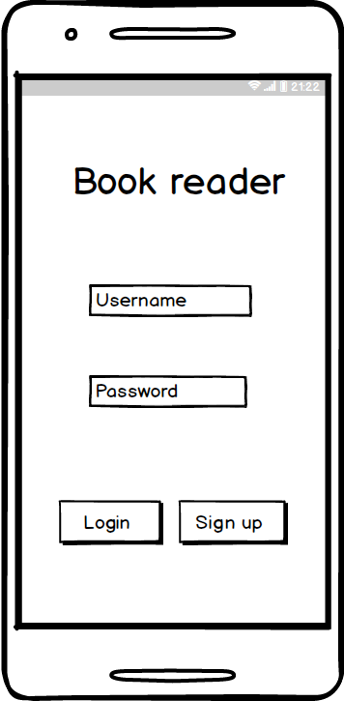

1. Signup

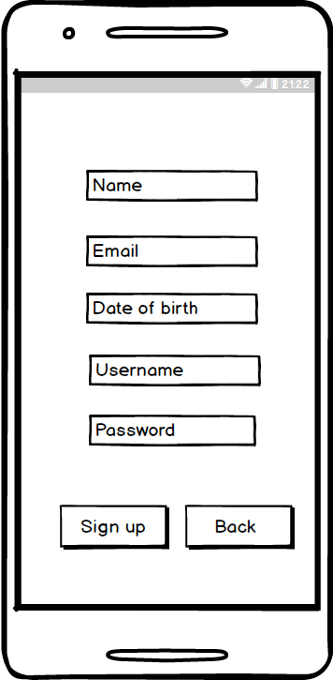

1. Dashboard

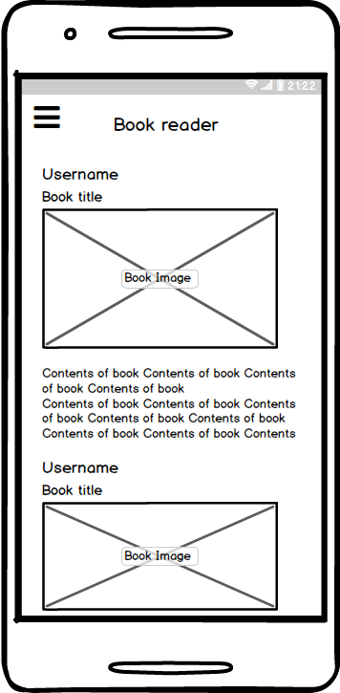

1. User profile

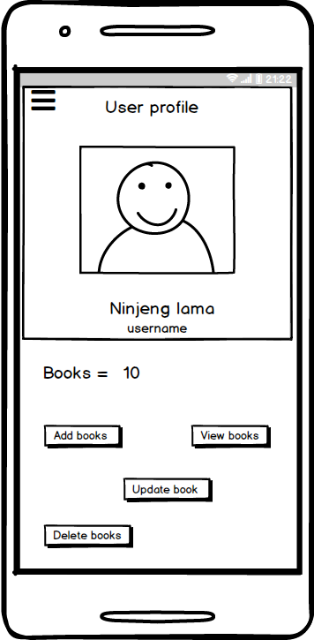

1. Add book

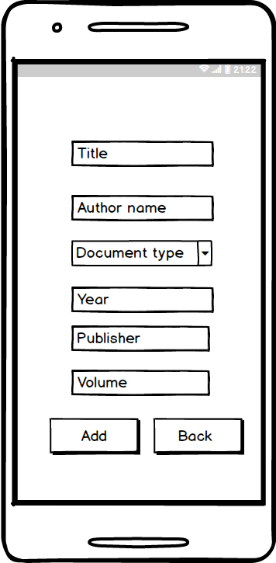

1. View book

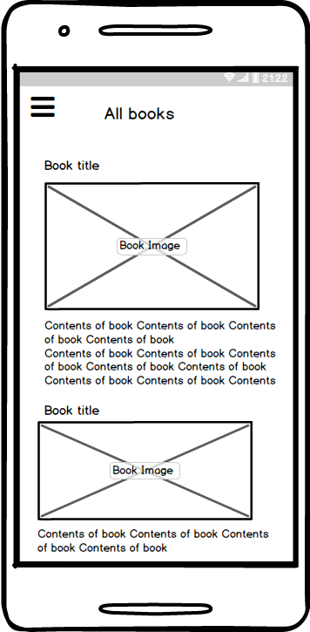

# Chapter 4: Implementation

## 4.1 Introduction

Implementation the part where magic happens to users. It is the part where coding or command are written to create software, websites, application etc. The coding is the way or method to communicate with the computer.

## 4.2 Programming language

There are many programming languages to create mobile application like Swift, JAVA, C#, C++, python etc. But I will be using Java because it the most popular language to create android application and due to its:

1. Security
2. Object oriented paradigms.
3. Classes and frameworks for features like networking, treading etc.

Android studio is the software where I have written my java code and xml code because

1. It is an official IDE (Integrated Development Environment) for facilitation app and game development.
2. It is a stable system which updates frequently to make the user more comfortable with the system.
3. The user interfaces are smooth.
4. It has an editor tools to create creative UI and emulators for different versions test.
5. Can use junit4, Mockito to unit test the application.

# 

# 4.3 Coding and user interface.

**Note: The coding and user interface is presented in the Appendix.**

# Chapter 5: Testing

Software testing is an activity to check whether the actual result match with the expected result. It involves execution of software components or system components to evaluate project. It helps to identify errors, gap, requirement etc. The types of software testing I will be using for the book reading system are: White box testing and black box testing. The main reasons to do testing is to reduce bugs which may cause harm and loss to the Book reading system.

## 1. White box testing.

It is the testing which involves the system, means the testing done to system components or code to compare the actual result and expected result. Since I have used Java as programming language to develop Book reading system. I have used Mockito for unit testing or white box testing because it is effective for Java application and it creates a dummy functionality which can be added to mock interface and use in unit testing.

The test plan for Unit testing of Book reader is shown below:

|  |  |  |  |  |  |
| --- | --- | --- | --- | --- | --- |
| S N | Test Case | Data | Expected | Actual Result | Date of testing |
| 1. | Should Show Error Message When Username Is Null | Null | Error message about username | Error message about username | 2019/7/1 |
| 2. | Should Show Error Message When Password Is Null | Username=Ninzen  Password=null | Error message about password | Error message about password | 2019/7/1 |
| 3. | Go To Dashboard When Username And Password Is Correct | Username=Ninzen  Password=password | Login successfully Goes to Dashboard activity | Login successfully Goes to Dashboard activity | 2019/7/1 |
| 4. | Show Error Message When Username or Password Is Incorrect | Username=123  Password=pass123 | Invalid username or password Error message | Invalid username or password Error message | 2019/7/1 |
| 5. | Should Show Error Message When Full Name Is Null When Creating New Account | Null | Error message to enter name | Error message to enter name | 2019/7/1 |
| 6. | Should Show Error Message When Email Is Null When Creating New Account | Name= Ninzen lama  Email =null | Error message to enter Email | Error message to enter Email | 2019/7/1 |
| 7. | Should Show Error Message When Email Is Not Valid When Creating New Account | Name = Ninzen lama  Email= ninzen.com | Error message to use a valid email | Error message to use a valid email | 2019/7/1 |
| 8. | Should Show Error Message When DOB Is Null When Creating New Account | Name =Ninzen lama  Email = [Ninzenlama21@gmail.com](mailto:Ninzenlama21@gmail.com)  Data of birth =null | Error message to enter date of birth | Error message to enter date of birth | 2019/7/1 |
| 9. | Should show error message when password is null when creating new account | Name = Ninzen lama  Email= [ninzenlama21@gmail.com](mailto:ninzenlama21@gmail.com)  Data of birth = 1999/08/23  Username = Ninzen  Password = null | Error message to enter password whole creating new user | Error message to enter password while creating new user | 2019/7/1 |
| 10. | Should show when Author is null | Title=Compute project  Author =Null | Error message to enter Author | Error message to enter Author while adding book | 2019/7/1 |
| 11. | Should show error message while publisher is null | Title = Computer project  Author = Ninjeng lama  Publisher = null | Show error message when publisher is null | Show error message when Publisher is null | 2019/7/1 |

The unit testing in android studio.

1. Test result of the unit testing.

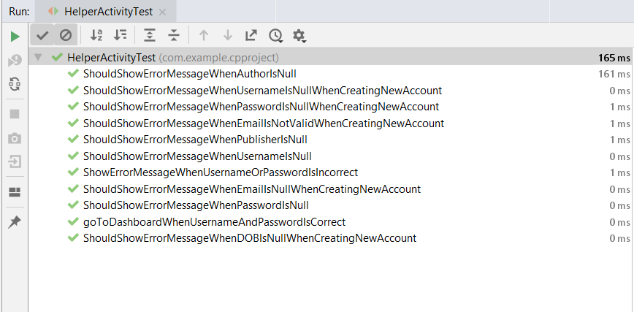

1. Helper Activity Test

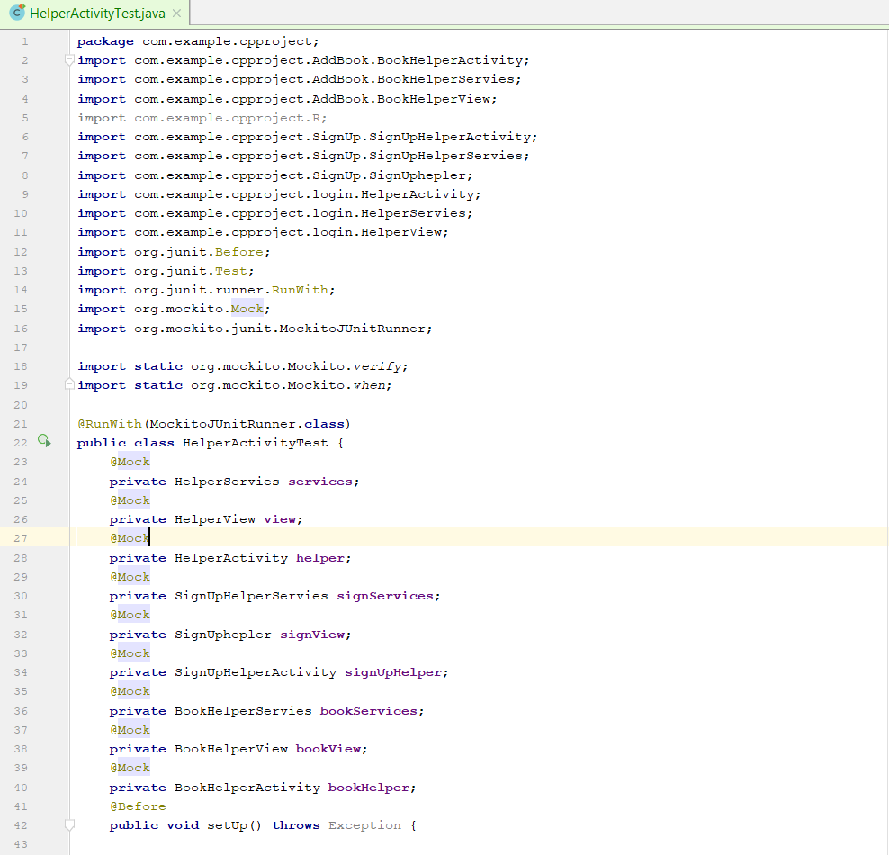

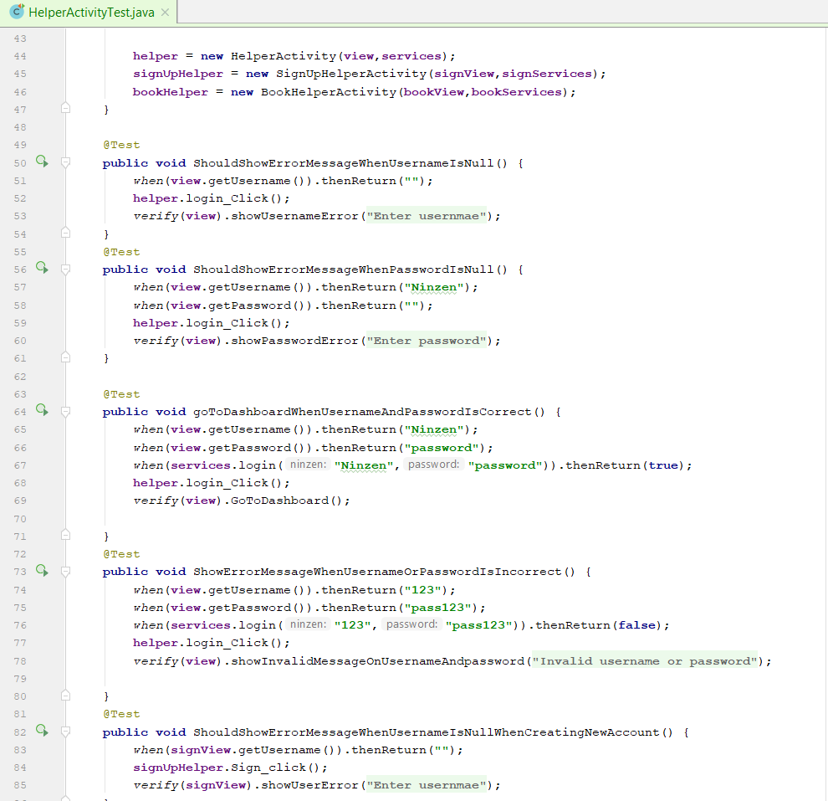

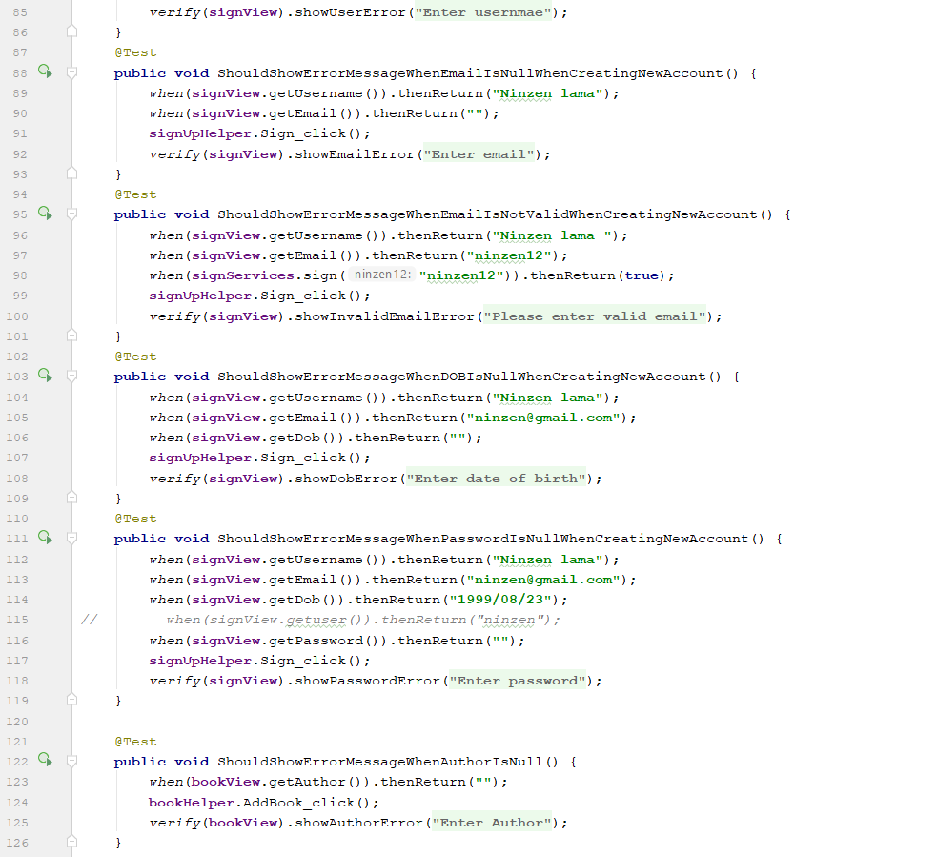

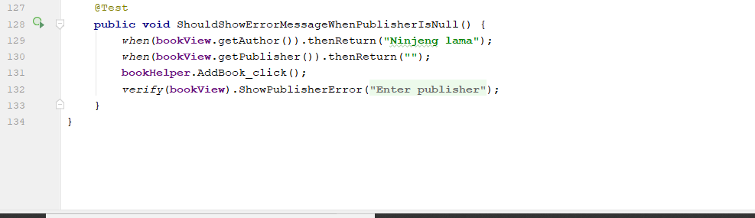

1. The Activity and interface used in Unit testing
2. Login

1.1 Helper Activity

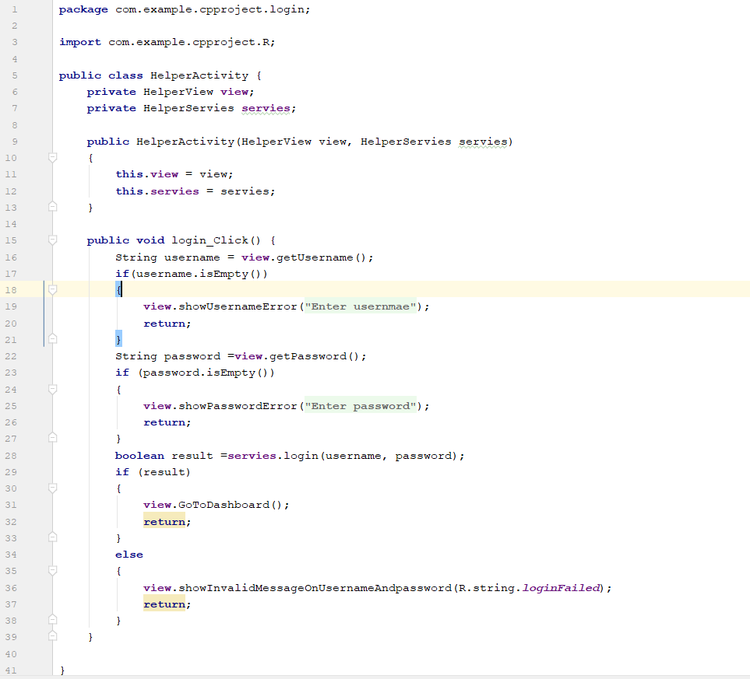

* 1. Helper services

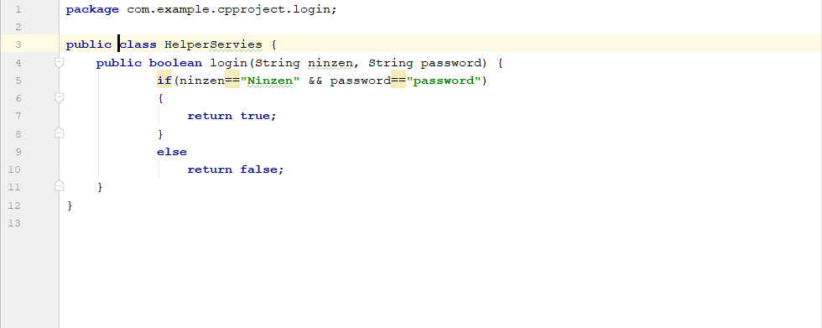

* 1. Helper View (Interface)

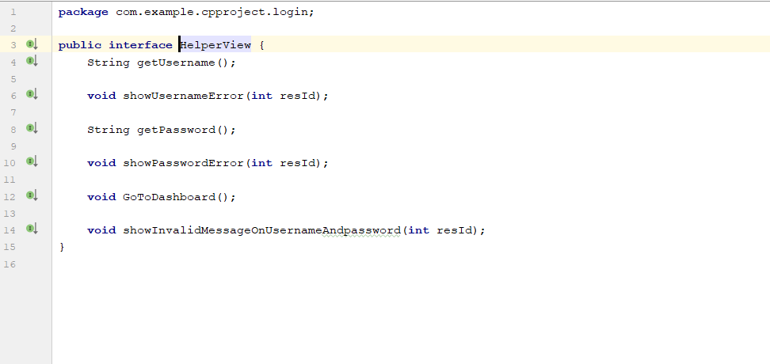

1. Sign
   1. Signup helper activity

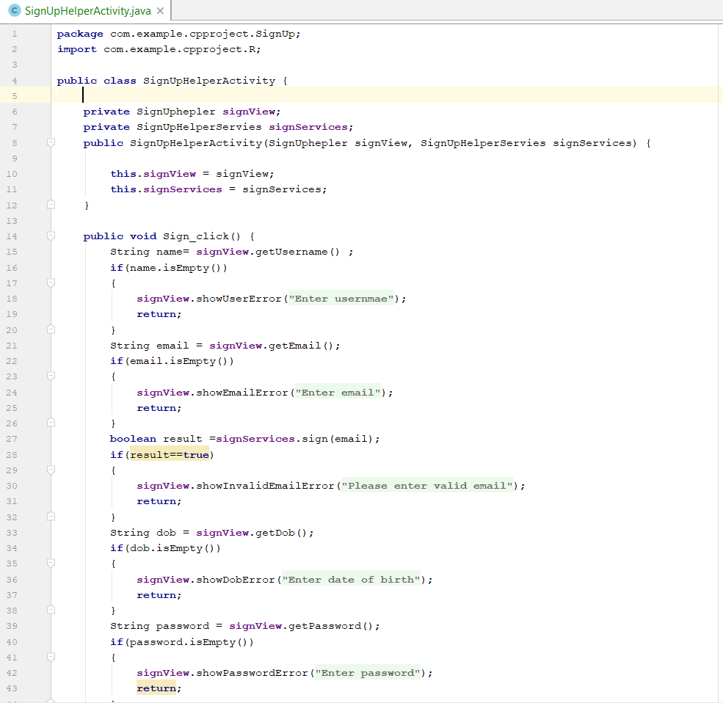

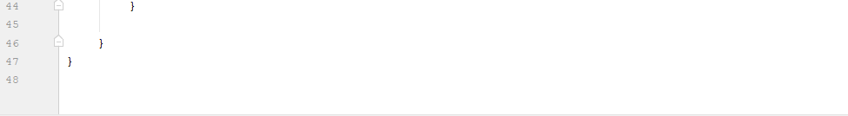

* 1. Signup helper (interface)

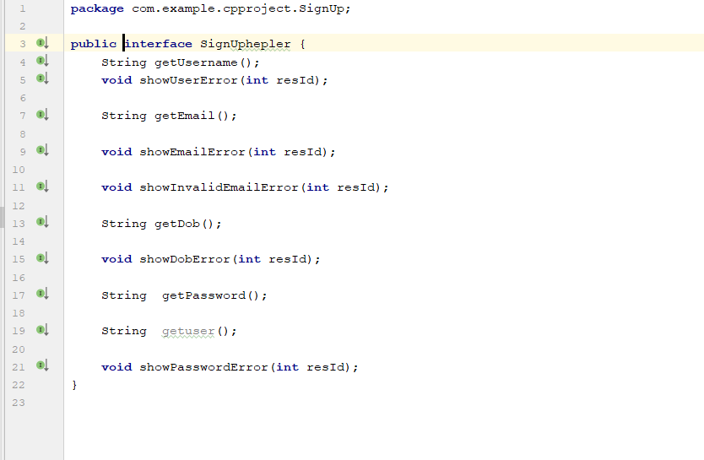

* 1. Signup helper services

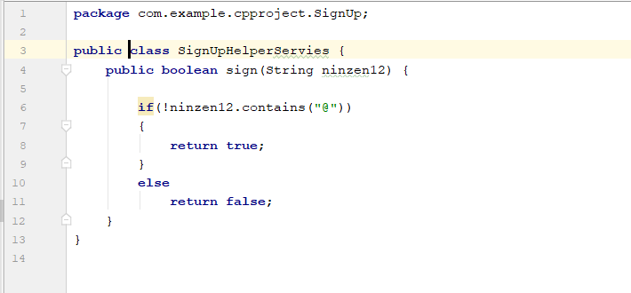

1. Add book
   1. Book helper activity

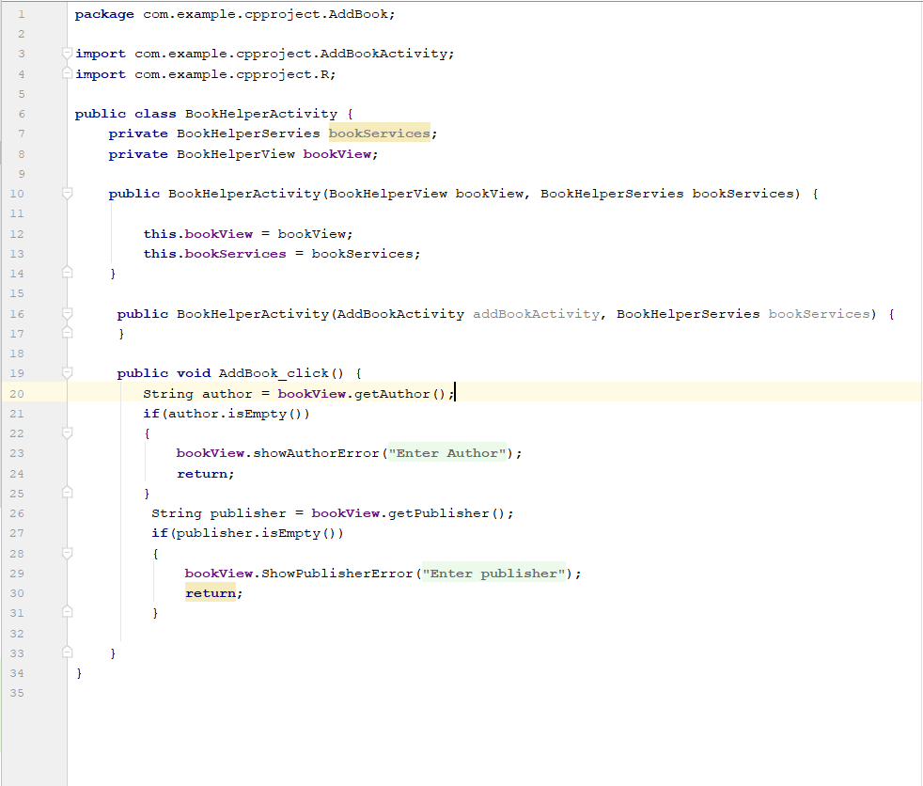

* 1. Book helper view

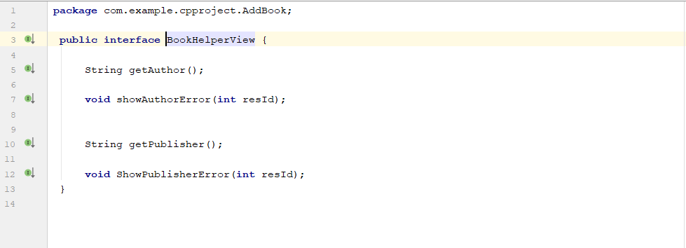

## 2. Black box testing.

Black box testing is known as the behavioral testing. The testing is done by the tester who test the software by the interface, design. This method attempts to find errors like Interface error, error in database, misfunctioning views etc.

The test plan of Book reading system for black box testing:

|  |  |  |  |  |  |
| --- | --- | --- | --- | --- | --- |
| S N | Test Case | Data | Expected | Actual Result | Date of testing |
| 1. | Show error message when username is null | Null | Error message to insert username | Error message to insert username | 2019/7/1 |
| 2. | Show error message when password is null | Username = ninzen  Password=null | Error message to insert password | Error message to insert password | 2019/7/1 |
| 3. | Open dashboard if password and username is correct | Username = ninzen  Password = password | Login successful | Login successful | 2019/7/1 |
| 4. | Show error message when password or username is invalid | Username = 123  Password =pass123 | Invalid username or password | Invalid username or password | 2019/7/1 |
| 5. | Download pdf file from online library | Click file | Downloaded | Downloaded | 2019/7/1 |
| 6. | Load all downloaded pdf files form online library | Retrieve data | Show all pdf files | Show all pdf files | 2019/7/1 |
| 7. | Open downloaded files | Click file | Open pdf | Open pdf | 2019/7/1 |
| 8. | Delete downloaded files | Click the delete button | Book has been deleted | Book has been deleted | 2019/7/1 |
| 9. | Add book | Click upload button | Book has been added | Book has been added | 2019/7/1 |
| 10. | Show error message when publisher is null | Publisher = null | Error message when publisher is null | Error message when publisher is null | 2019/7/1 |

1. Show error message when username is null.

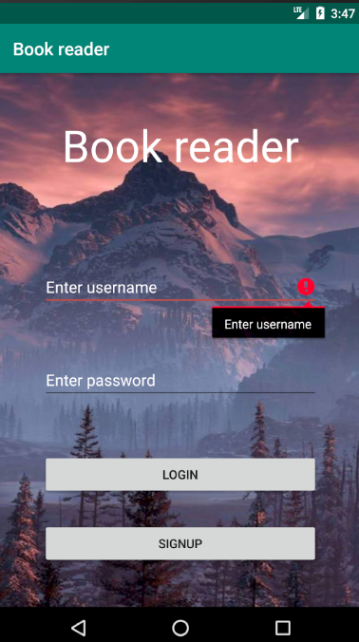

1. Show error message when password is null.

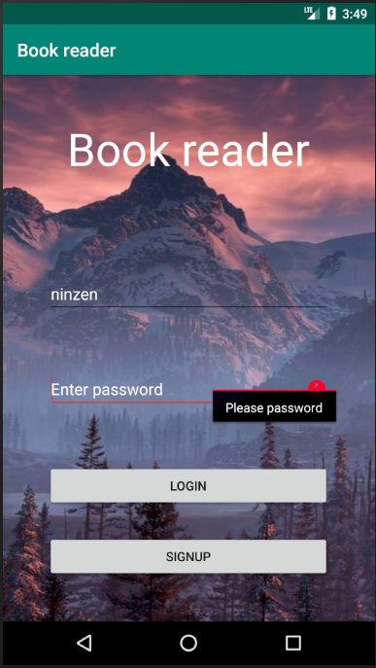

1. Open dashboard if password and username is correct.

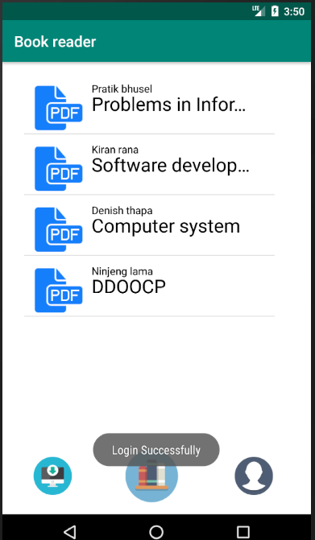

1. Show error message when password or username is invalid.

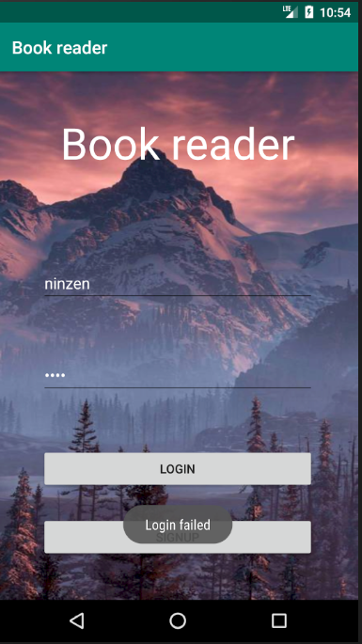

1. Download pdf file from online library.

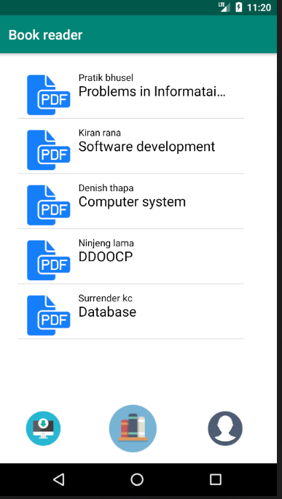

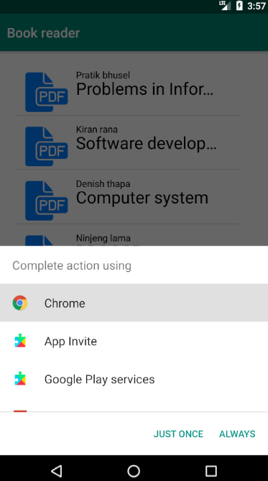

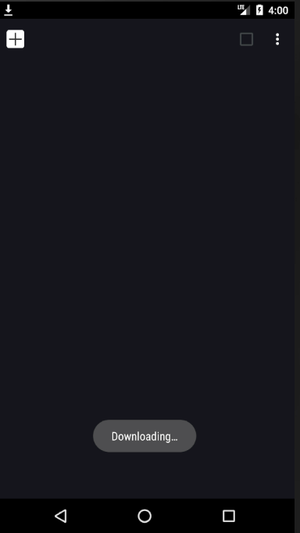

1. Load all downloaded pdf files form online library.

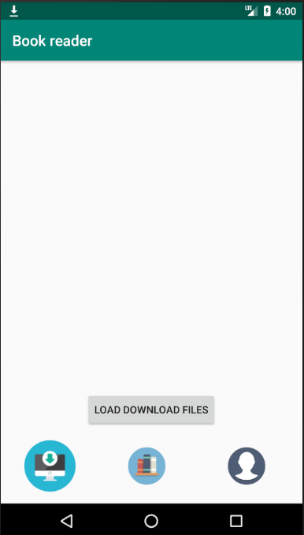

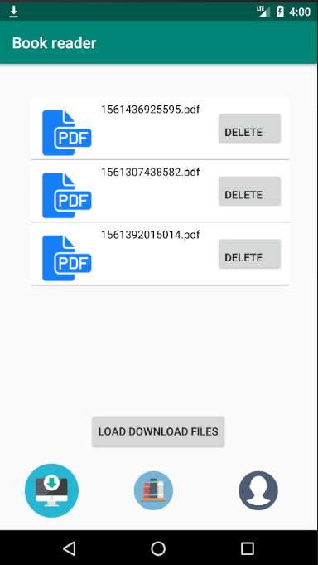

1. Open downloaded files.

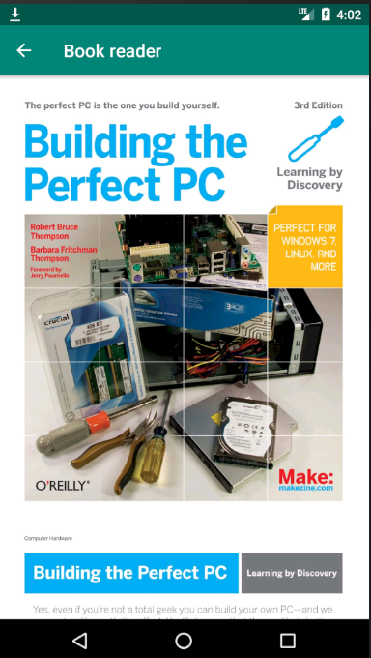

1. Delete downloaded files.

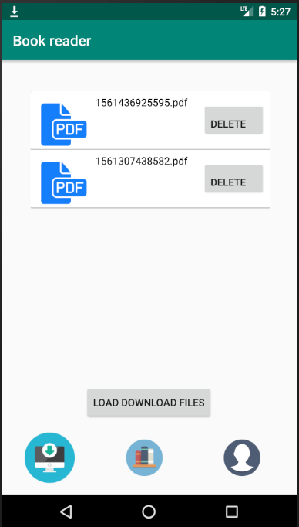

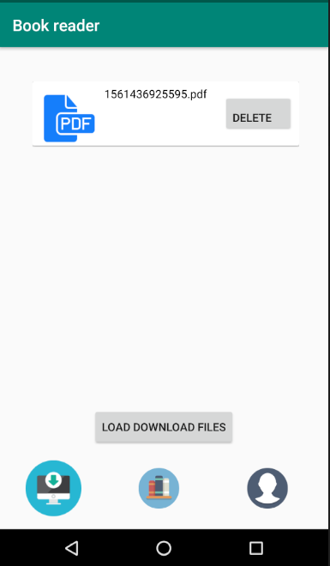

1. Add book.

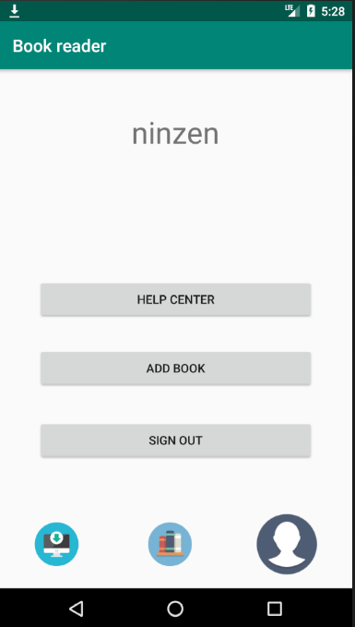

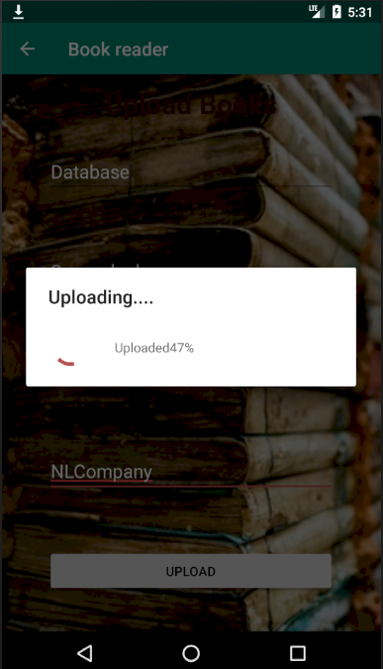

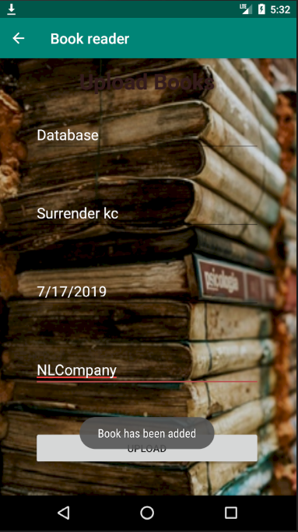

1. Show error message when publisher is null.

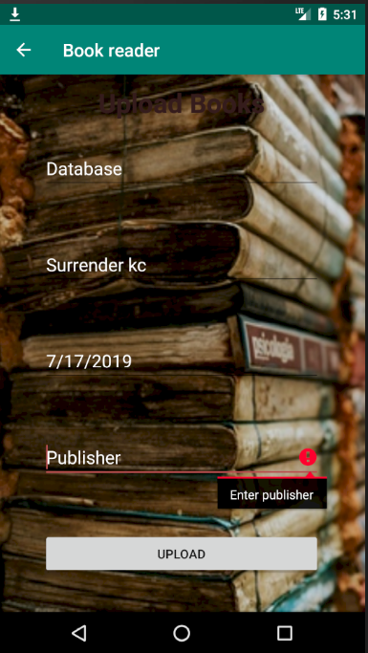

# Chapter 6: Other project issues

## 6.1 Risk management

Project risk management is the process of identifying, analyzing and then responding to any risk that arises over the life cycle of a project to help the project remain on track and meet its goal. Risk management isn’t reactive only; it should be part of the planning process to figure out risk that might happen in the project and how to control that risk if it in fact occurs.

To estimate the impact of each identified risk we use

Impact = Livelihood x Consequences

Livelihood table

|  |  |
| --- | --- |
| Livelihood | Value |
| Low | 1 |
| Medium | 2 |
| High | 3 |

Consequences table

|  |  |
| --- | --- |
| Consequences | Value |
| Very low | 1 |
| Low | 2 |
| Medium | 3 |
| High | 4 |
| Very high | 5 |

|  |  |  |  |  |
| --- | --- | --- | --- | --- |
| Risk | Livelihood | Consequences | Impact | Action |
| SQLite Database failure | 3 | 4 | 12 | Due to unrecognizing the file of SQLite database by android studio. I have use Firebase services to store users and books data online. |
| Insufficient time | 2 | 4 | 8 | Due to loss of time to learn JAVA.I could not complete all the tasks that I have presented in the proposal. I have completed all the tasks that are of Must have from MoSCoW prioritization. |
| Operating system not supporting | 3 | 5 | 15 | Since I had Windows 10 Home which does not support Android studio, so I had to change my operating system to Windows 10 pro. |

## 6.2 Configuration management

Software configuration management is the process used by software engineers to which manage the files and folders of a project in a standard way so that the organization can make changes accordingly. It helps to identify individual elements, track changes, version control etc. The configuration of the book reading system is shown in the following figure using Command prompt.

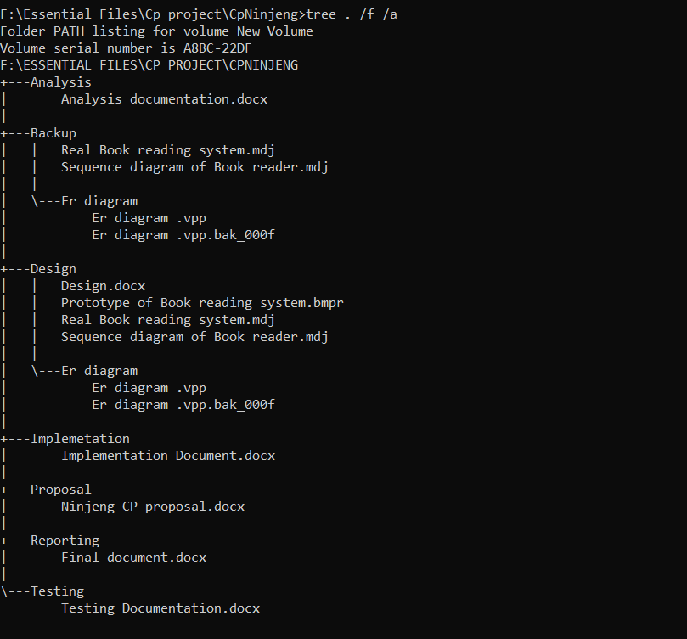

## 6.3 Project issues

There were many issues that I have faces during the development. Since this was the new programming language to me and new software tool, from where I had to develop an application so during the installing of the software tool android studio the tool was not responding properly so I researched and found out that it does not support in windows 10 home which was my operating system that time so I changed my operating system to windows 10 pro so that android studio can be supported. Another issue arises when I was storing user data the data base file was not supporting by the android studio, so I used Firebase database to store user and books data. Due to immature decision of mine I could not manage time which lead me to another issue where I could not add additional feature to the application so to make the app more fun to use.

## 6.4 Limitation

The world itself is not perfect everything has its limitation so does the Book reader application so of the limitation of the book reading system are:

1. No admin:

So, to make an open source application I had to remove admin from the book reading system. So that the user can manipulate the application and make there own or for personal use which create a scenario that the only user can delete their own books not others and the books can only be delete by accessing the firebase console.

1. Can’t read book online:

Since the book are saved in the firebase storing system to access it the user must download the file first so reading book directly online cannot be done.

## 6.5 Future work

The Book reading system was completed successfully but due to short period of time I couldn’t add additional features which could made the application more interesting to use. Some of the features I would likely to add in the coming future are:

1. Voice reader: this function will read the books contents so that user could listen them any time.
2. Categories to separate books types so that user can search there wanted books by genres.
3. Adding more layouts in the PDFViewer to make it attractive.
4. Online payment system: Since some of the books can only be redden or downloaded after it is paid so I will add payment system for paid books in the future.
5. I will add forums to reviews about books and feedback about the system.

# Chapter 7: Conclusion

Generally, I face problems while reading books in the public areas, traveling etc. sometimes the books are heavy, some time I get bored of reading due to the same styles in books. So, I thought to myself why not create an application which will help me to read book easily.

So, I created an application which will make reading easier for general persons, students and me so that they can read any books, anywhere, any time. They don’t have to go libraries, bookstores to buy or read books they just can login into book reader application and find the book h/she want to read within his’s/she’s mobile. For those who are new to the application there is a user guide which tells how to use the application. The application store books and its data in the firebase console from where all the user can read the books. Since during the development process our semester has just started. And in order to make time for the semester studies and develop book reading system I miss analysed the time management which insufficient time and could not add Voice reader feature in the application but beside this all the development process is completed successfully. So due to my miscalculation the project has taught on how to utilize the time and where to utilize the time. And I have built up an experience in android application development and will learn more about android development and make the book reading application more interactive and user friendly.

# Appendix

## Codes:

1. Activity PDF

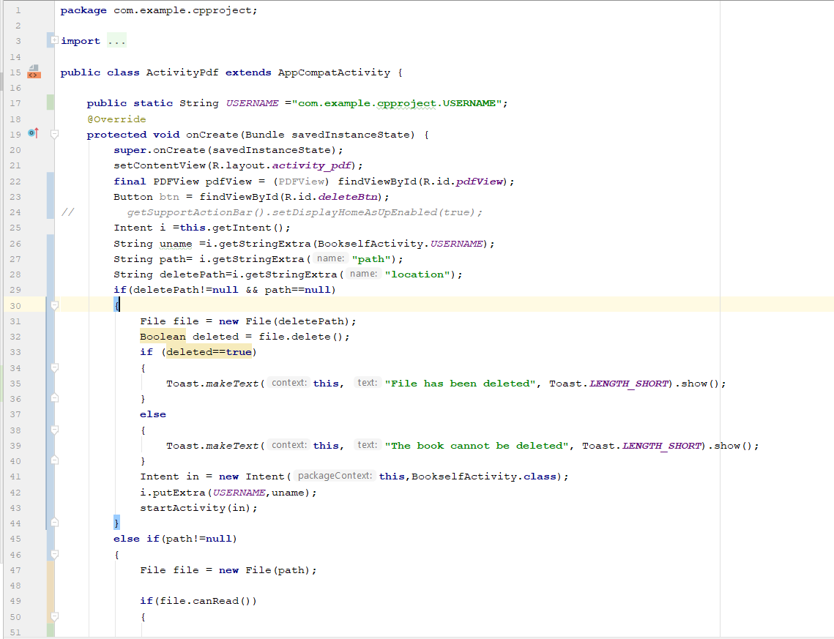

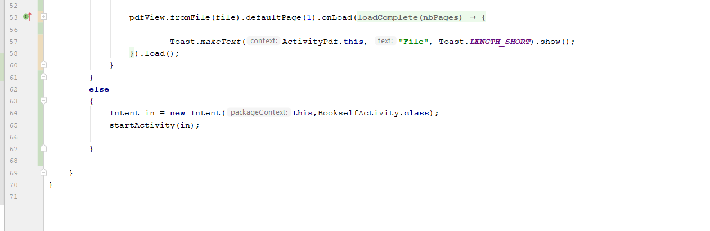

1. Add book activity

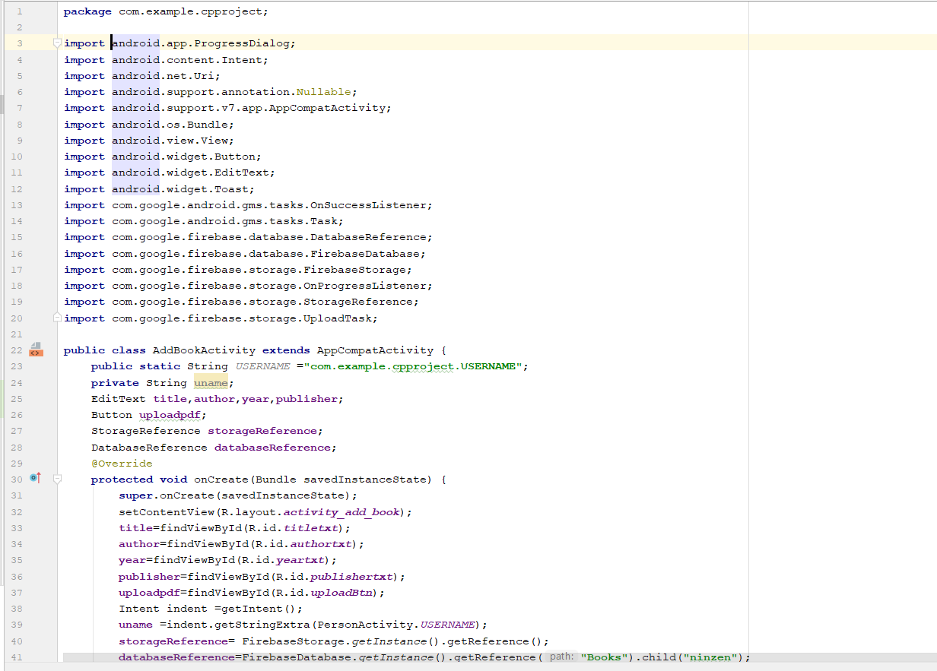

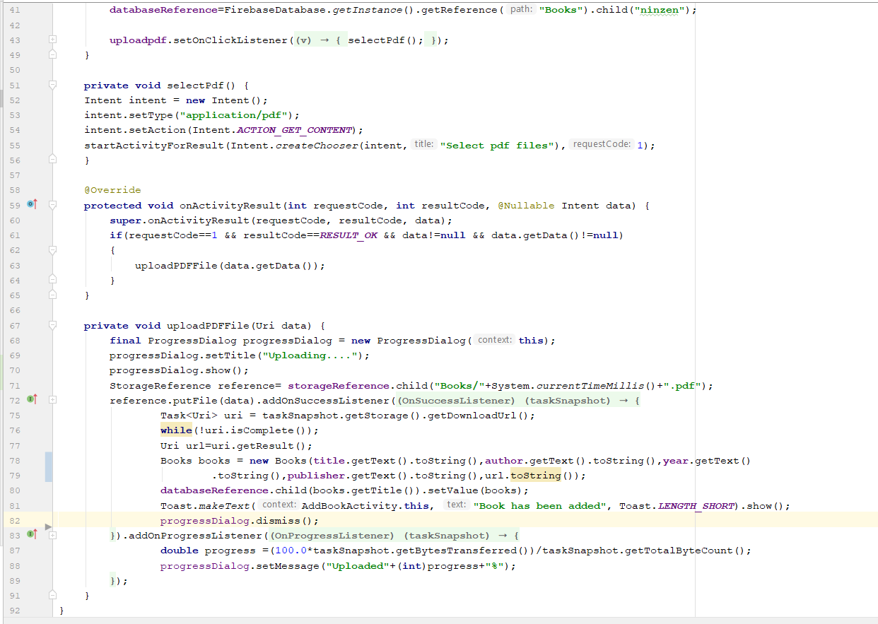

1. Book activity

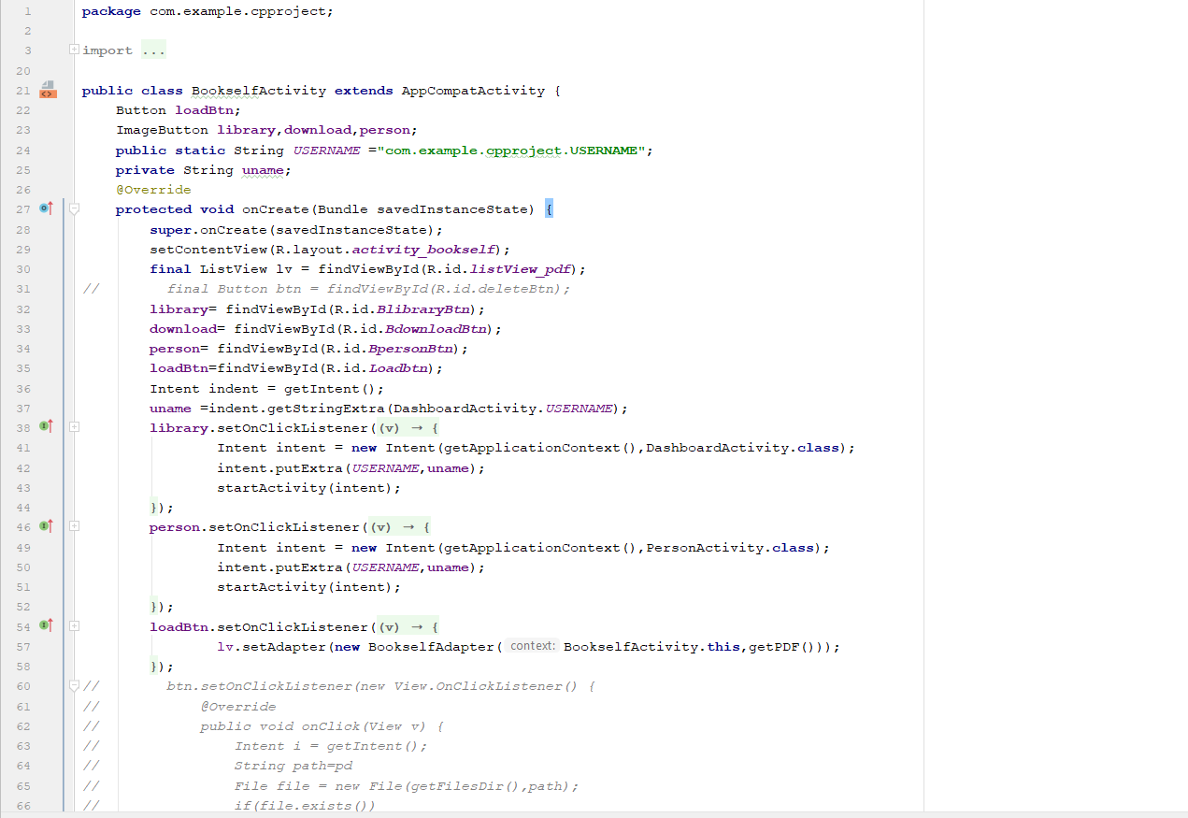

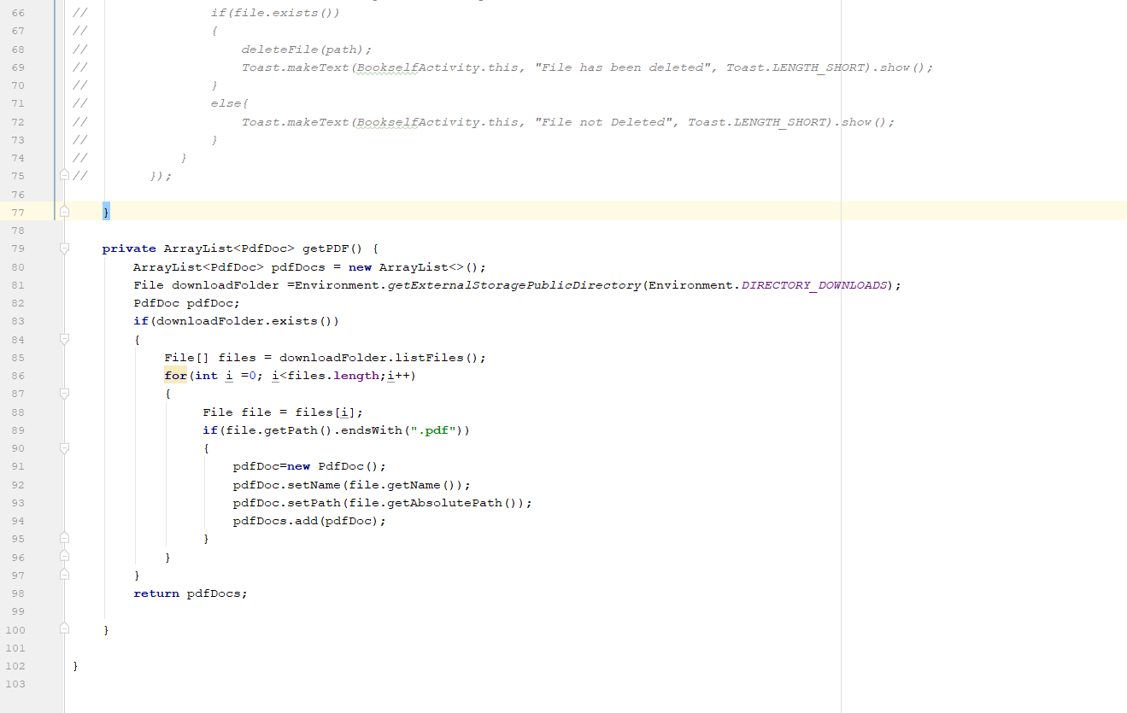

1. Book list

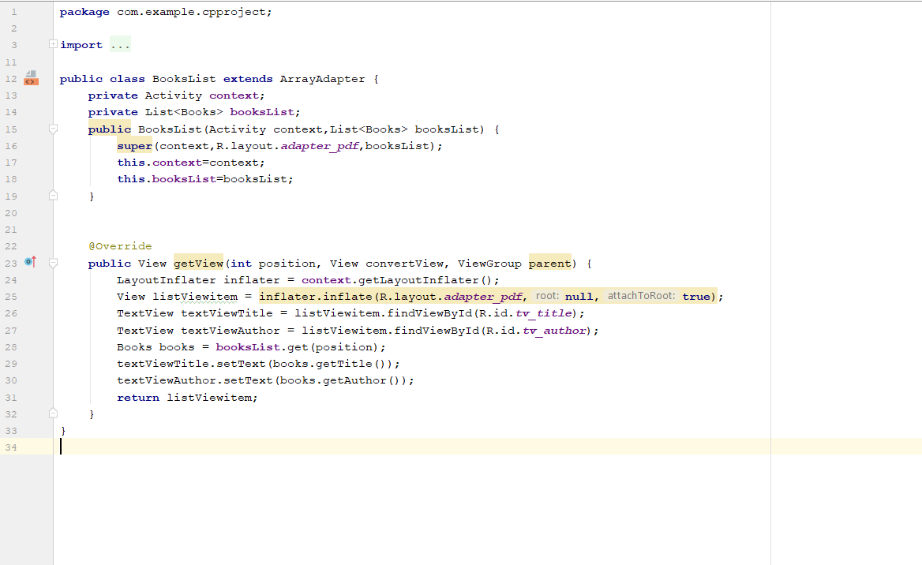

1. Books

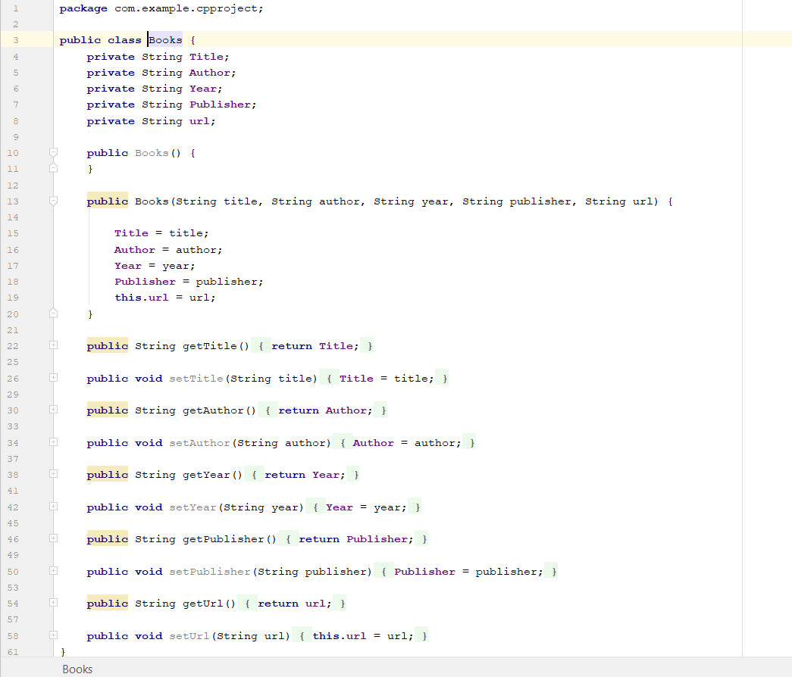

1. Book self-activity

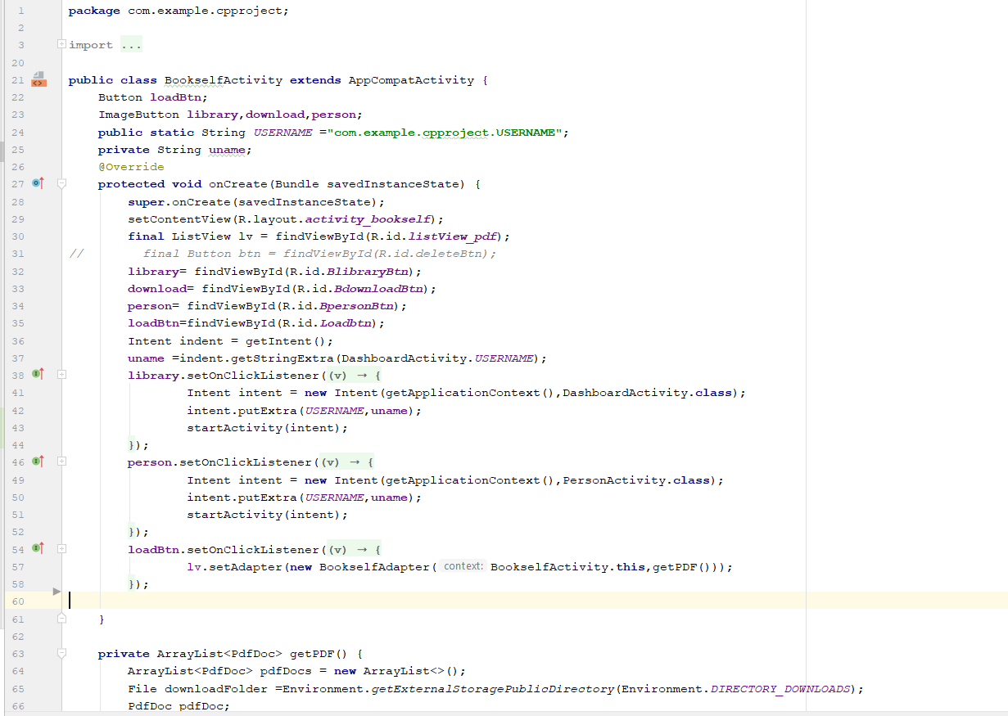

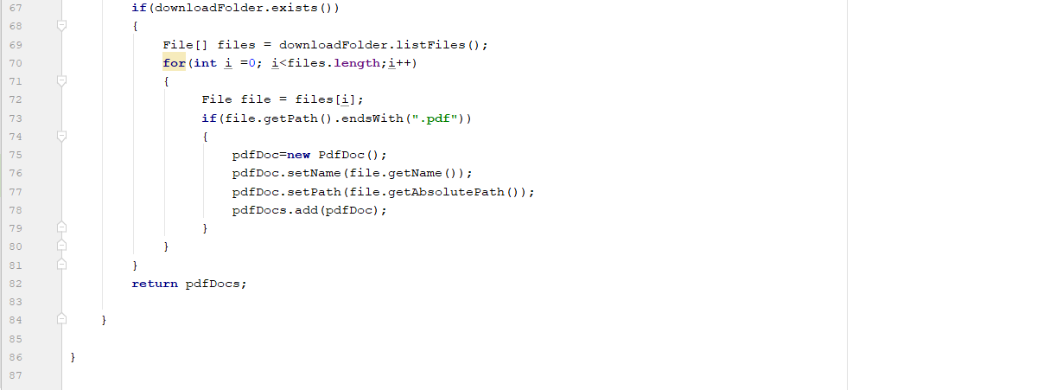

1. Book self-adapter

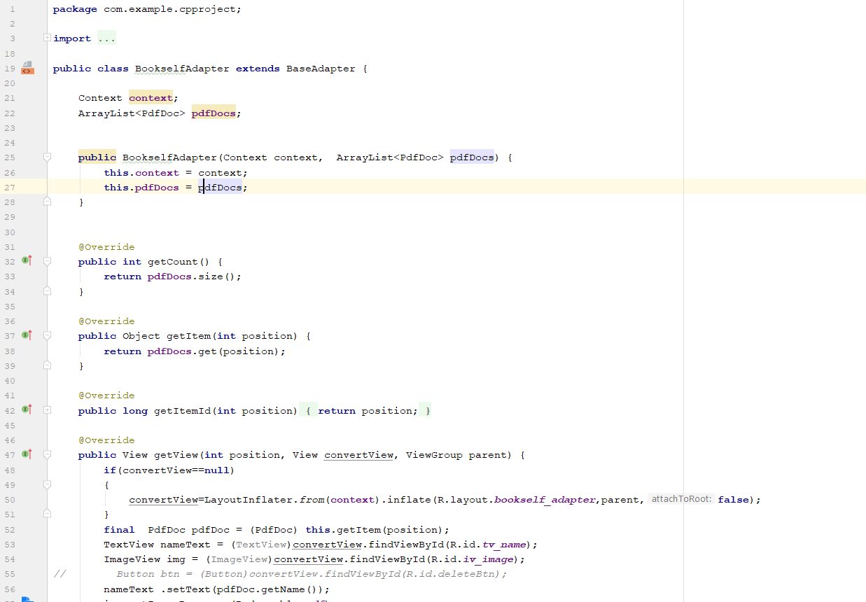

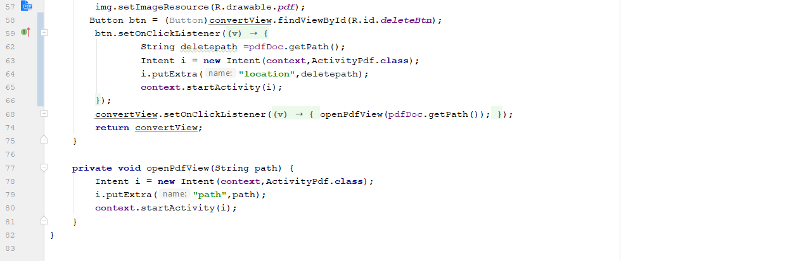

1. Dashboard Activity

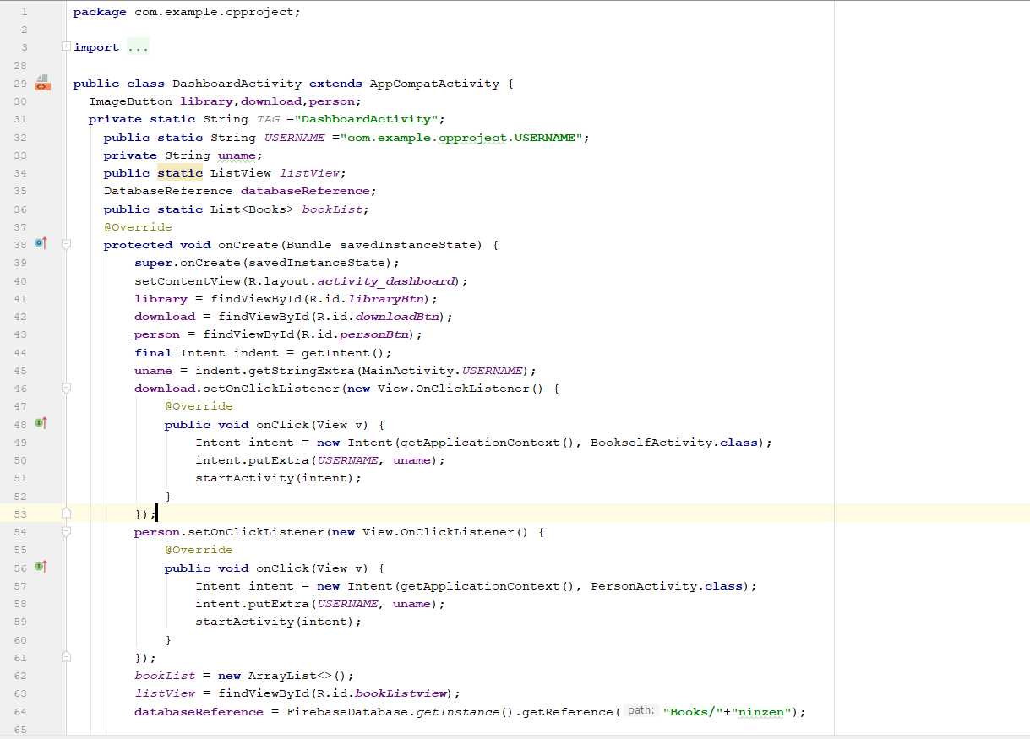

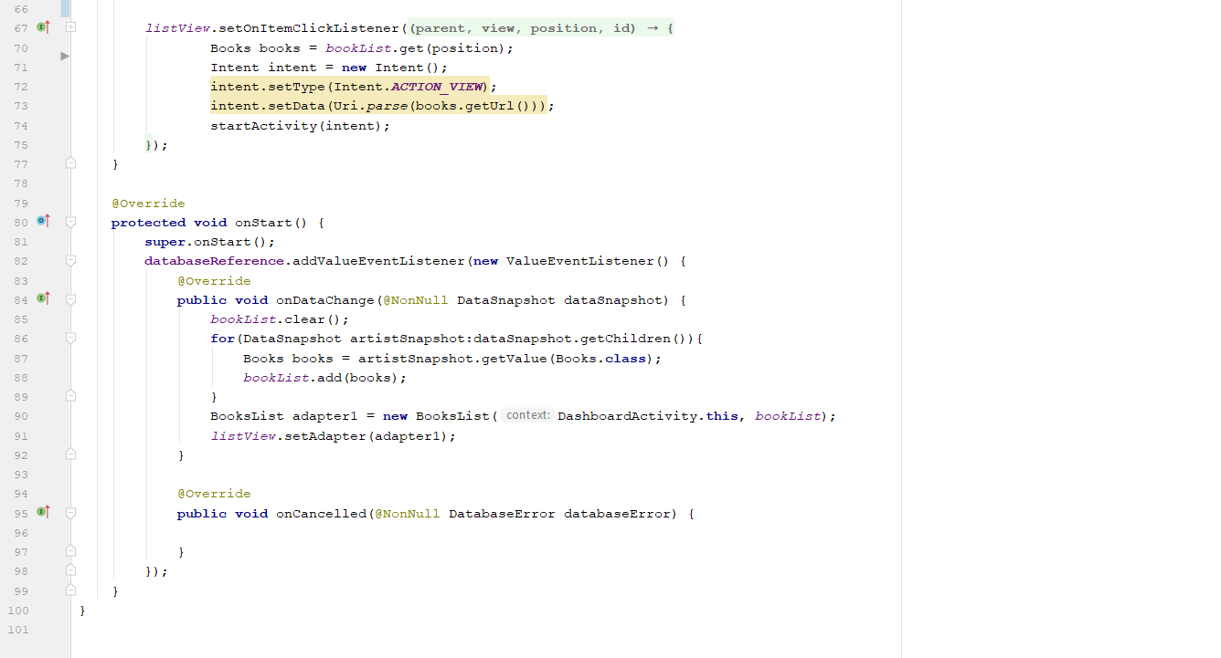

1. Help Centre

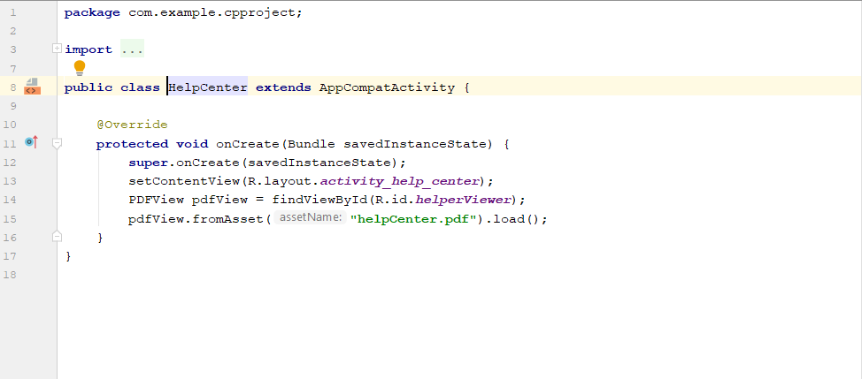

1. PdfDoc

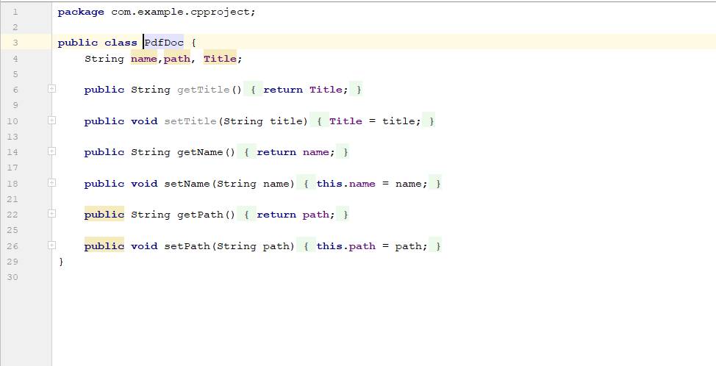

1. Main activity

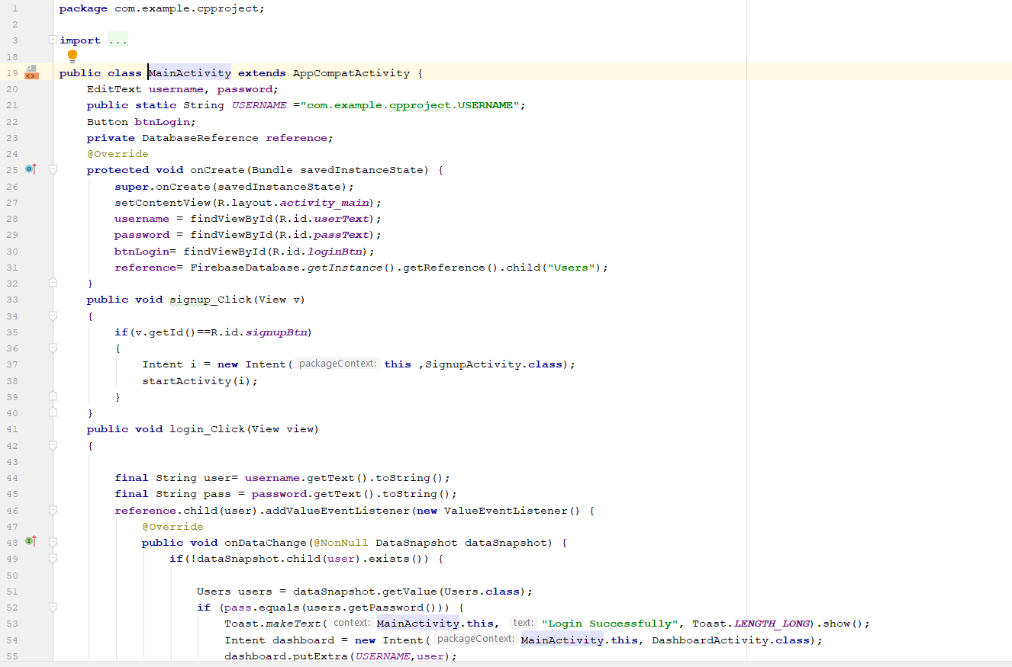

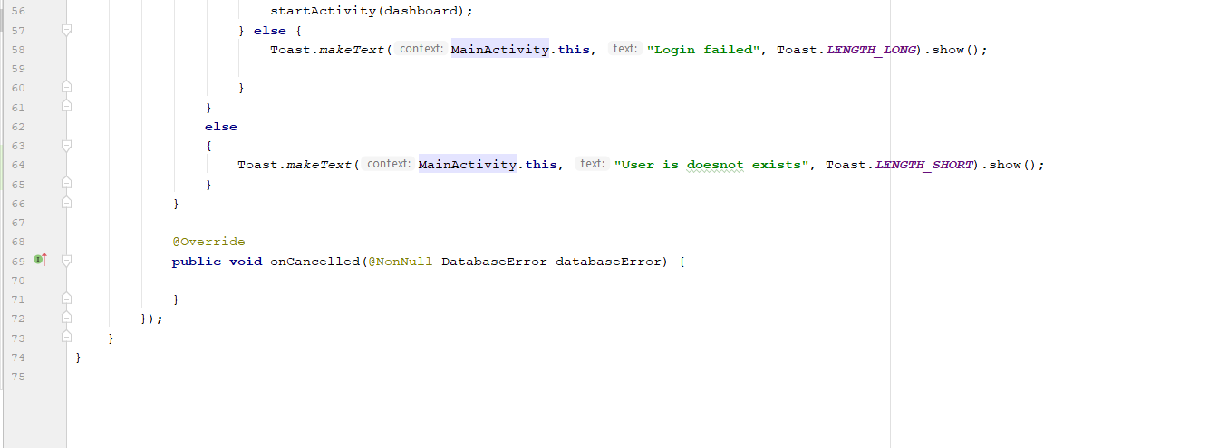

1. Pdf Adapter

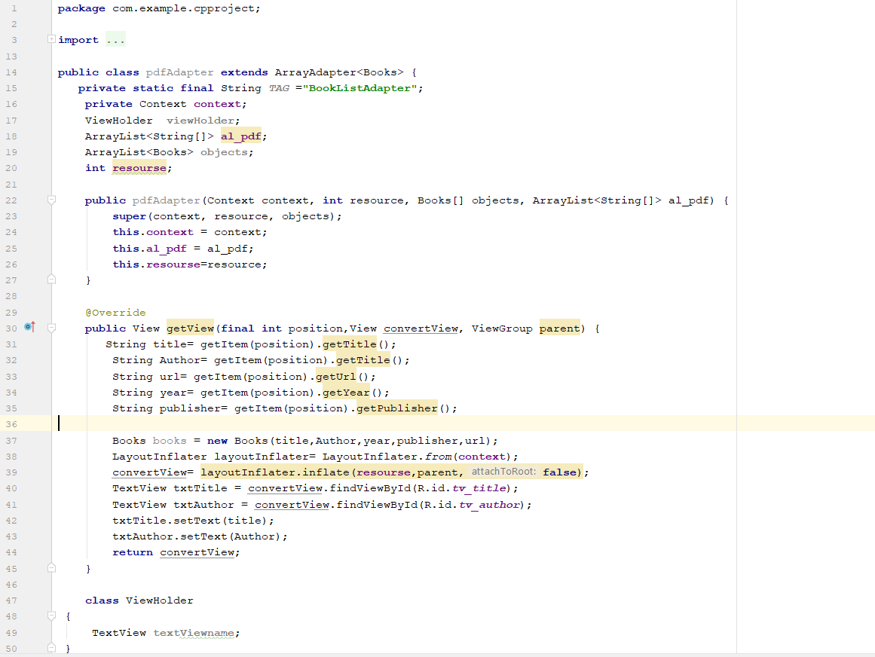

1. Person activity

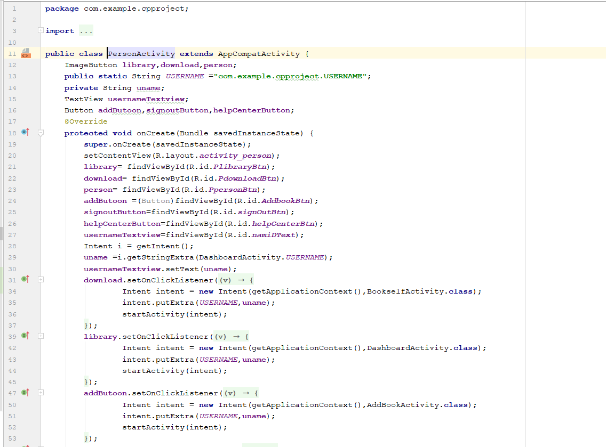

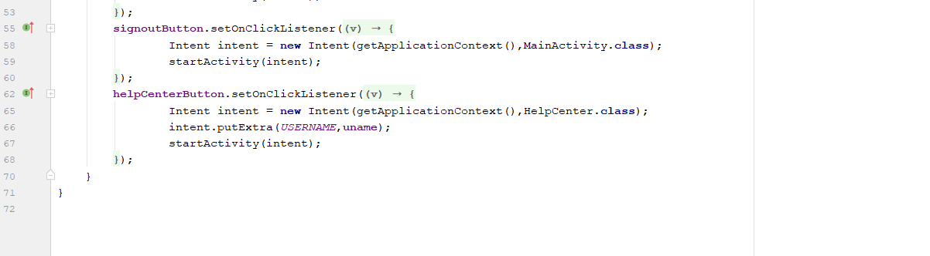

1. Signup activity

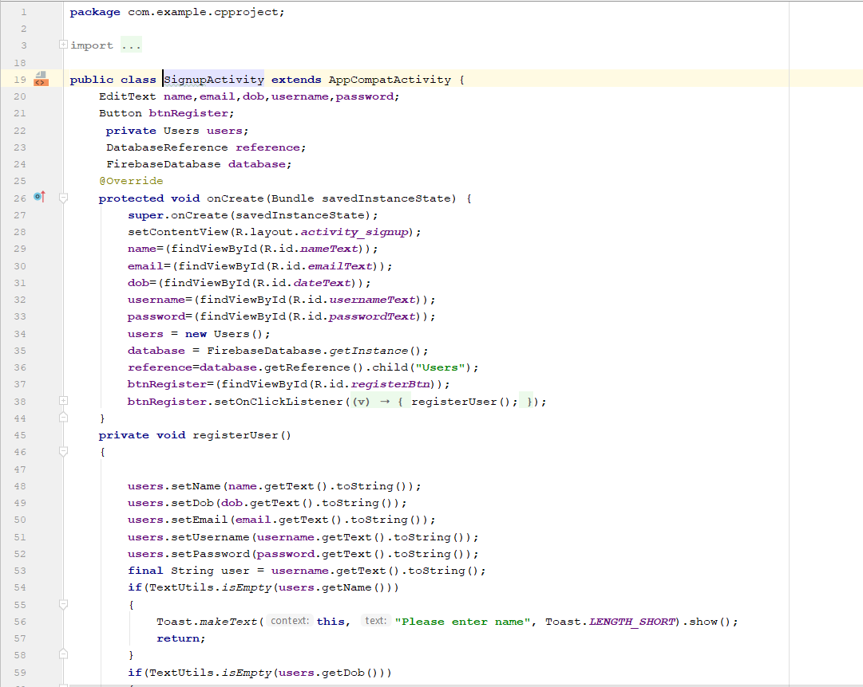

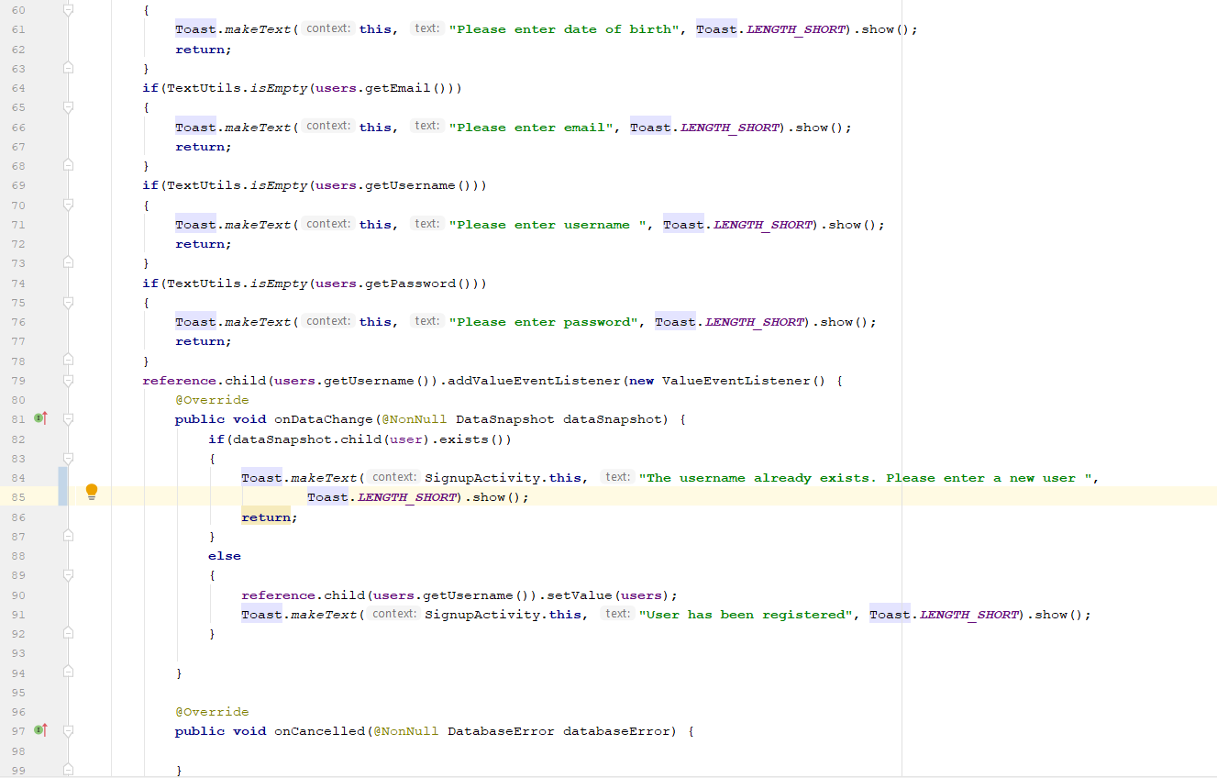



1. Users

